the ajoona guest house
a u g u s t 9 - 2 1 , 2 0 2 2
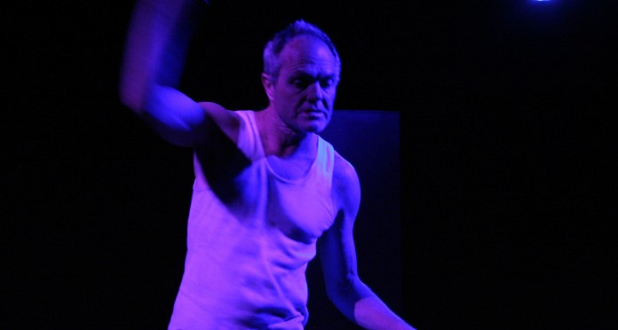
Written by Stephen House
Directed by Rosalba Clemente
Performed by Stephen House
Lighting design by Julian Adams
Sound design by Alain Valodze
Thank you:
La Mama Theatre, Asialink, Arts SA, City of West
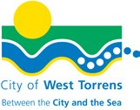
Torrens And you, the audience
A note from playwright and actor, Stephen House
‘The Ajoona Guest House’ is my third play in a trilogy of stand-alone monologues, set and written in three world cities over ten years: the first, ‘Appalling Behaviour’ (Paris), the second, ‘Almost Face to Face’ (Dublin), and now the final. It has been such an adventure in so many ways! All three have been programmed by La Mama and toured widely. The Ajoona Guest House has been a wonderful journey for me as a playwright / actor: receiving an Asialink India literature residency and writing the piece in New Delhi, an Arts SA grant to develop and produce the world premiere in Adelaide, playing to a sold-out first season, recently touring as part of the 2022 Darwin Fringe hub program, and being published by, In Case of Emergency Press. Director, Rosalba Clemente read the monologue after it was written, and immediately said she would love to direct it. We had always wanted to work together, so this was exciting. Alain Valodze then came on board to create sound. It felt like the perfect combination for a new work, and it was. Our process was amazing. I am delighted to be performing at La Mama HQ. This incredible company has been in my theatre-making life for decades. It is always an honour to be here. Thanks, La Mama Theatre for having me back, and hosting the Melbourne premiere of The Ajoona Guest House, and to Julian Adams for coming on board as lighting designer and tech for this season. And a special thanks to you, the audience, for coming along to see it.
Stephen House has won many awards as a poet, playwright, and actor, including: two Awgie Awards from The Australian Writer’s Guild, Rhonda Jancovic Poetry Award, an Adelaide Fringe Award, and The Goolwa Poetry Cup. Nominations include: a Greenroom Best Actor Award, Tom Collins Poetry Prize, Patrick White Playwright Award, and Queensland Premier’s Drama Award. He’s received several international residencies from The Australia Council, and an Asialink India residency. His plays and poetry are published often. His chapbooks, ‘real and unreal’ and ‘The Ajoona Guest House’ have been published by ICOE Press. He performs his monologues widely.

Rosalba Clemente has a long and acclaimed career in the Performing Arts. She has been well awarded for her work as a freelance actor, director and writer. She has been privileged to hold positions of leadership including Artistic Director of State Theatre SA, Head of Acting at Drama Centre and Chair of the Theatre Board at Australia Council. Her motivating passion has been the assisting and creation of new Australian works which have including World Premier Seasons of My Vicious Angel by Christine Evans, Radiance by Louis Nowra, Holy Day by Andrew Bovell. She has loved working on The Ajoona Guest House with Stephen.
Alain Valodze has been playing guitar since a young age. ‘Having explored and performed an eclectic variety of styles and genres he is a guitarist drawing influences from Flamenco, Brazilian, Classical, Jazz, Indian and Latin styles, CREATING a hauntingly beautiful New Age and contemporary sound. As a composer his work has been used in a variety of multimedia from film, television., live theatre and digital applications. His work has also been acknowledged by Unesco as a peace initiative in the form of an award during the Covid pandemic as part of a collaboration with international artists.
Julian Adams is an honours graduate of La Trobe University’s Bachelor of Arts, having also completed a diploma of Live Theatre Services with Melbourne Polytechnic. A jack-of-all-trades and self-confessed theatre addict, Julian is always looking for a new opportunity to challenge his skills. His recent successes include designs for In Blood (La Mama, 2022) Appellations (MICF, 2022), Monash in Love and War (Chapel Off Chapel), PLAF’s Creatures of the Night/Deep/Lost (Fringe) and acting as Medvedenko in The Seagull (La Mama) and Samson 2 in ManDogMan (MonsterFest). He thanks you for your patronage and hopes you enjoy the show.

Office Phone: (03) 9347 6948
Office Hours: Mon – Fri | 11am – 4pm
Box Office opens 4pm on performance nights, 12pm for Playreadings and 2pm Sundays
205 Faraday Street, Carlton VIC 3053 www.lamama.com.au | info@lamama.com.au
La Mama Theatre is on traditional land of the people of the Kulin Nation. We give our respect to the Elders of these traditional lands and to all First Nations people past, present and future. We acknowledge all events take place on stolen lands and that sovereignty was never ceded.
La Mama is financially assisted by the Australian Government through the Restart Investment to Sustain and Expand (RISE) Fund - an Australian Government initiative, the Victorian Government through Creative Victoria, and the City of Melbourne through the Arts and Creative Partnerships Program.
We are grateful to all our philanthropic partners and donors, advocates, volunteers, audiences, artists and our entire community. Thank you!

