Louisa’s dawn
a u g u s t 3 - 1 4 , 2 0 2 2
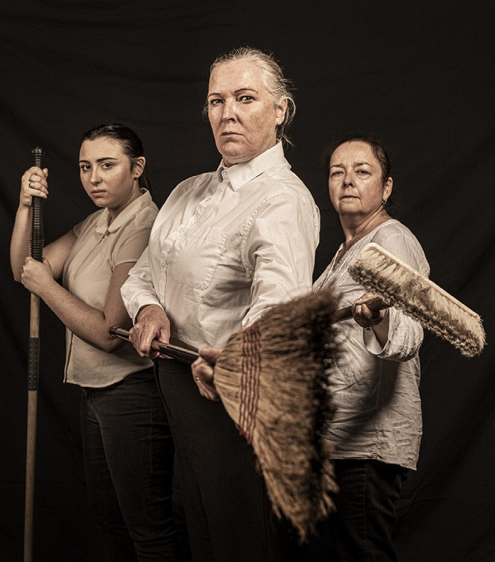
LOUISA’S DAWN
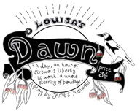
Written by James Howard
Directed/Produced by Ann Chadwick
Musical Direction and original music by George Williams
Performed by Gin O’Brien, Tayla Harry, Peppa Sindar, Mary-Rose McLaren, Graham Maxwell, Adam Menegazzo & Kate Parkins
Stage manager Marco Pezzimenti
Set design by Ann Chadwick
Costuming by Tayla Harry and the ensemble Sound design by George Williams and Ann Chadwick Soundscape and Musical support Adam Menegazzo
Photography credit Darren Gill

The poem ‘Coming Home’ was written by Louisa Lawson. Her poem ‘The Final Hour’ has been adapted to song by George Williams.
‘The March of the Women’ was the suffragette anthem and ‘Solidarity for Ever’ a union anthem.

Director’s Notes:
I have collaborated with James Howard on theatre projects over a friendship of more than 40 years. James brought me the script for Louisa’s Dawn and asked me if I would direct it for a season at La Mama.

Louisa Lawson’s words are the blueprint for this show. They come from the articles she wrote and speeches she delivered. James and I discussed his ideas for the play which included the use of music and comedy to add brightness to the story and that it be presented in a revue-style. In this interpretation of the script, some connections have been added between scenes.

This is a play with many characters brought to life by seven performers and uses well-known theatre devices such as changing hats and “Greek Chorus”. It has been a challenging script to bring to life, representing a busy printing press, crowds of unionists and demonstrators. Louisa’s Dawn presents women under siege in the 19th century, striving to have their voices heard. The themes remain relevant today.

- Ann Chadwick
James Howard (He/him) Writer. James, a Footscray writer, actor, and filmmaker, became interested in Louisa Lawson through his work with and interest in the writings of Henry Lawson. James has been influenced by the work of James Joyce, Shakespeare, Irish and Russian playwrights. He is sensitive to injustice and believes that all humans should be respected equally. His later writing for performance has been influenced by his early involvement with New Theatre in Melbourne and Crewes Dramatic Company, based at the fledgling Footscray Community Art Centre.
Ann Chadwick (She/her) Director/Producer studied drama at Victoria University as a part of her BA. Since then, she has been involved in all aspects of theatre, on stage and off. She has collaborated with people of all ages and abilities and, as a solo artist, to tell stories through performance. Ann wrote the play Nude in Decline specifically to be presented in art galleries. Ann directed Nude in Decline for its successful premier season at Ballarat Art Gallery in December 2021.
George Williams (She/they) Musical Director/Composer is a composer, performer, educator, choir leader, writer, and community arts collaborator with a Bachelor in Music Performance from the University of Melbourne (VCA) and is currently studying a Masters of Creative Arts Therapy. Her published works include UNESCO world heritage project SongWays which mapped the music history of Ballarat, and the e-book Ballarat Memorial Concert Band: a century of music. She is the co-founder and creative director for Virtual Soul Choir and recently undertook the Creative Workers in Schools program through Regional Arts Victoria. George has also been Musical Director/ Composer for various theatre productions.

Gin O’Brien (She/her) Louisa Lawson moved to Ballarat in 2017 after living in Ireland for 20 years. Since then, she has been involved as a performer in Steel Magnolias, A Christmas Carol, and Medea for Ballarat National Theatre. She was also Assistant Choreographer for Ballarat Lyric Theatre’s production of Jekyll and Hyde in 2019. In her youth, Gin worked as a professional dancer throughout Asia, Egypt and on cruise ships in the Mediterranean. Being tall and strong were necessary attributes then and Gin is delighted that she can use the same qualities to bring Louisa Lawson to life in this production.
Mary-Rose McLaren (She /her) Mary Ferguson, Chorus, and a man at the Debating Club is an associate professor at Victoria University and teaches arts-based movement, and creativity units in Early Childhood Education and in the Diploma of Education Studies. She is also an actor, writer and director and works extensively in community theatre. Mary-Rose wrote and directed One Boy’s War (BNT 2013) based on letters from her grandfather to her father during World War II. Her first book of poetry, Windows and Mirrors, was published in 2019.
Peppa Sindar (She/her) Miss Grieg, Chorus, and a man at the Debating Club has performed in Melbourne and regional Victoria, including Shepparton Arts Festival, Benalla Theatre Season, Castlemaine Fringe, Daylesford Words in Winter, and the 2012 International Georgetown Festival in Penang. Melbourne and touring productions with New Performance have included Waste Not Want Not (Midsumma Festival) and The Life I’d Like to Have and The Play’s the Thing (both La Mama). She has been seen in telemovies, commercials, and series and with classical music ensembles in words-and- music programmes for festivals.
Tayla Harry (She/her) Gertrude Lawson, Chorus graduated from Monash University with a Bachelor of Arts and was part of the final cohort to partake in CTP’s Musical Theatre Program. She has been an active part of MUST (Monash Uni Student Theatre) throughout her time at Monash. She has also worked with Born in a Taxi to create online works such as Systems People and Take Me to Your Leader as part of the 2021 Melbourne Comedy festival line-up. She also has a passion for costuming. Tayla is looking forward to bringing Gertrude to life and to help tell Louisa’s story.
Kate Parkins (She/her) Musician, Frail Man (debating club), unionist, Josephine Wilson is a post-doctoral researcher at The University of Melbourne. Her research focuses on animal ecology and bushfire risk. Kate also has an acting for stage and screen degree from Charles Sturt University. She has a love of theatre and music and has performed most recently in the A is for Atlas production of ‘VOYAGE: The Actual and Properly Truthful Account of the Emigration of Thomas Pender’ - a devised ensemble performance about Australia’s history of emigration, performed at fortyfivedownstairs in Melbourne.
Graham Maxwell (He/him) Orlando, Thomas Haviland, Henry Parkes, John Marshall, unionist, William Lane. Graham’s interest in telling stories has been lifelong. Being a natural ham with many guises, he has sung, acted, and played in pipe Bands, Swing Bands, National Events, Choirs, Musical Theatre, Drama, and some television commercials. In recent years he’s been proud to be part of new works with Ballarat National Theatre (Who Remembers The Great War, Honourable Mentions) as well as Mary-Rose McLaren’s adaption of A Christmas Carol and her direction of Daisy Pulls It Off.

Marco Pezzimenti (He/him) Stage Manager
Theatre has always been a passion for Marco. Being involved in any aspect of theatre has inspired him to further himself through study with his current course in screen, media and performance at La Trobe. He has also been actively involved in community theatre projects. He embraced this opportunity to contribute to the technical aspect of performance with enthusiasm.
Adam Menegazzo (He/him) Musician, unionist, Peter Sinclair, Supporter of Louisa is a classically trained violinist. His musical interests range from gypsy to indie rock, from folk to improvised soundscapes. With loop pedals and melodies, he takes you to a world where melancholy, joy, and beauty reign. Adam is a co-founding member of an indie rock collective, Alpha Hall who are about to record their 3rd album. Other recent projects include - Klezmer Balkan Gypsy ensemble, Words in Winter Festival, and audio-visual collaborations and guest appearances. With a passion for the performing arts, Adam is combining his love of music with his interest and enthusiasm for theatre.
Katie Williams (They/them) Lighting design is an early career technical arts professional. They have experience in a wide variety of roles in the live productions industry; most recently having directed Bright Star (Theatre of the Damned), stage managed and operated for Talking to the Future (La Mama CH), lighting designed, operated and stage managed for Jane Eyre (La Mama CH) and lighting designed for Louisa’s Dawn (La Mama CH).
Thank you:
Geoffrey Williams, Ben Lehtonen, Linda Bagu Batson, Sandra Fitzpatrick.

Office Phone: (03) 9347 6948
Office Hours: Mon – Fri | 11am – 4pm
Box Office opens 4pm on performance nights, 12pm
for Playreadings and 2pm Sundays
205 Faraday Street, Carlton VIC 3053 www.lamama.com.au | info@lamama.com.au
La Mama Theatre is on traditional land of the people of the Kulin Nation. We give our respect to the Elders of these traditional lands and to all First Nations people past, present and future. We acknowledge all events take place on stolen lands and that sovereignty was never ceded.
La Mama is financially assisted by the Australian Government through the Restart Investment to Sustain and Expand (RISE) Fund - an Australian Government initiative, the Victorian Government through Creative Victoria, and the City of Melbourne through the Arts and Creative Partnerships Program.
We are grateful to all our philanthropic partners and donors, advocates, volunteers, audiences, artists and our entire community. Thank you!

