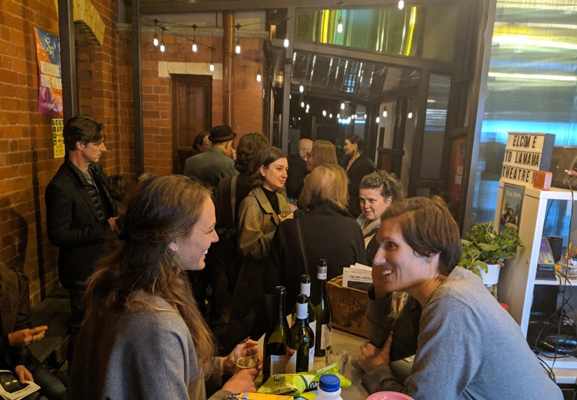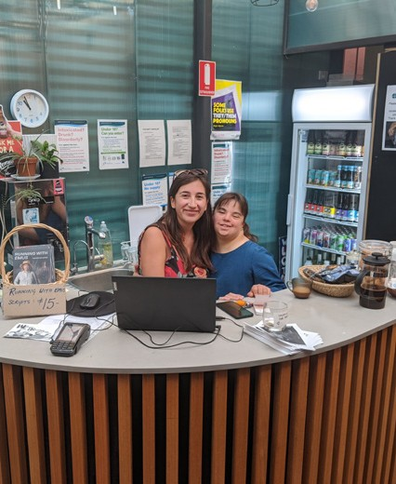Front of House Pack

Wominjeka
La Mama Theatre is on traditional land of the Kulin Nation. We give our respect to the Elders of this country and to all First Nations people past, present and future. We acknowledge all events take place on stolen lands and that sovereignty was never ceded.

La Mama is financially assisted by the Australian Government through the Australia Council – its arts funding and advisory body, Restart Investment to Sustain and Expand (RISE) Fund - an Australian Government initiative, the Victorian Government through Creative Victoria, and the City of Melbourne through the Arts and Creative Investment Partnerships program. We are grateful to all our philanthropic partners and donors, advocates, volunteers, audiences, artists and our entire community. Thank you!
Office Phone: (03) 9347 6948
Office Hours: Mon – Fri | 11am – 4pm
La Mama HQ 205 Faraday St, Carlton VIC 3053
www.lamama.com.au | info@lamama.com.au

Introduction

In this pack is information relevant to the Front of House operations of
your show during its season at La Mama.

We will support your show in every way we can and strive to provide an exceptional experience for your team, and each audience member every night.

Amber Hart
Front of House and Volunteer Manager
Working days Tuesday - Friday (Weds from home) e | amber@lamama.com.au

What to Expect from Front of House (FOH)
There will be two FOH looking after your show every night and our focus is to support your team to have the best experience possible. It is likely you will have different FOH staff each night so it is important that the stage manager consistently communicates the same information each show to the FOH once they arrive.

Your FOH team will manage the following tasks:
- Operate the bar and box office.
- Communicate with your Stage Manager before show time about specific needs for the
show.
- Usher audience into the theatre. It is ideal to start letting audience into the theatre at least 10 minutes before show time. Talk to me if this doesn’t work for your show.
- Before the show begins one of the team will do an Acknowledgement of Country and the La Mama Raffle.
- Each show must provide a raffle prize for every performance. This can be something related to the themes of your show and is a traditional highlight, have fun with it and give it some special consideration.
- FOH will sit in the two reserved seats in the front row of the theatre closest to the audience entry during the show. For safety reasons all outside doors will be locked. It is important that if an actor does a cross over through the bar area that you tell FOH, so they don’t lock them out of the theatre. We have more reserved signs if you need them for your actors or crew.
  - After the show has finished one of the FOH team will thank the audience and invite them back to the bar to mingle with the cast and crew.
It is part of La Mama’s philosophy that audiences are always invited to stay for a drink or a free cuppa post show to socialise and converse with the Artists of the production. There is no expectation for the Artists to stay for a length of time, but as a long standing La Mama tradition it is important that they emerge to the foyer post show. So please communicate this to the whole team so they know what the expectation is for the season.
- On opening nights, we will serve free drinks to everyone after the show. All cast and crew are entitled to discounted drinks for $5 throughout the rest of the season.
- FOH will then close the bar and box office area and lock up. It is the SM’s responsibility to lock the cast side. It’s also important that both FOH and Stage Manager leave together to ensure everyone’s safety.

Ticketing and Venue Supervisor Information
We have recently employed two new staff, Gemma Horbury and Aya Taur for an exciting
new role as the ticketing and venue supervision team.

One of these two will be on the premises every show day, and you can call on them if you need any help with any issues that may arise and they will come and support you through it, whether it’s a technical issue, medical issue, or anything that you feel you would like some support with.
They will be rostered on as the 2nd FOH for most shows and will be at La Mama HQ from 4pm on weekdays and 12pm or 4pm on Saturdays depending on whether there is a playreading or not, and from 2pm on Sundays.
They will be primarily based at La Mama HQ but available to support at the Courthouse as needed. If they are at the other venue please call the La Mama landline number (03) 9347 6948 and follow the prompt to box office/ticketing to get a hold of them.

Other Requests For Your Show

It’s helpful to know early if there are any specific needs for your show so we can make sure
the night runs smoothly for all.

For example:

- If you want specific pre-show music at FOH. We have a Spotify account so if you create
a playlist you can share this with us.
- If you are selling scripts or merch. It is preferable that you provide someone each night who can do this via a square reader or bank transfer directly into your account.
- If you are using Haze or replica weapons, (please read La Mama’s content warning policy and notify Sophia so that the appropriate communications with audience can be made (email: sophia@lamama.com.au).

I will send you an email the Friday before you bump in that asks you show specific questions for your season that will assist our FOH team to help make your season run super smoothly. If we can discuss beforehand how best to set these things up for your show it is always ideal.

The template you will receive is below :)

Stage Manager:
Pronouns:
SM mobile:
Run time:
Raffle prize:
Raffle Location:
Pre/post show music:

Other things to think about:

- Do any of my actors need access to the theatre during the show from an external door? We need to know so we don’t lock them out!
- La Mama FOH will do a raffle and Acknowledgement of Country inside the theatre before the show starts. If you would like to discuss a variation to this please let me know in advance.
- Please make sure the Marketing team have your updated content warnings
- Is there anything else that FOH should know??
- Please ask your Stage Manager to make themselves known to FOH before each show to discuss the above notes

La Mama Aircons
These must be on for every show where the temperature outside is warm or cool and are non-negotiable over Winter and Summer.

It is the stage manager’s responsibility to put them on as soon as they arrive at La Mama or La Mama Courthouse, the Courthouse in particular takes a while to heat or cool so the earlier the better.

FOH will check they are on at a suitable temperature, it is an occupational health and safety hazard when they are not on. Please do your best to make the spaces as comfortable as possible, so the audience can enjoy your wonderful production the way it deserves.
Volunteers

We have access to a myriad of talented people itching to get involved so please contact
Amber if you’d like some help bringing your production to life.

Having a specific schedule and profile for what you are looking for in a volunteer is helpful and saves time so have a think about what you need and when, then get that information to me via an email and we will make magic happen!

Please reach out if you have any questions about your season at La Mama. We can’t wait to see your show! Xx

