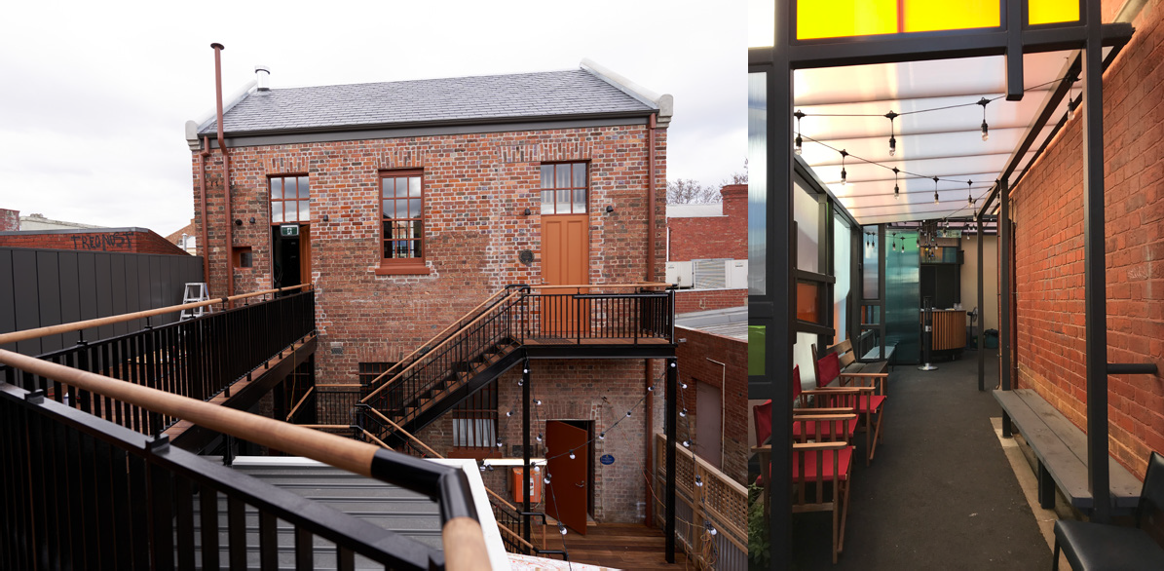marketing information pack

Wominjeka
La Mama Theatre is on traditional land of the Kulin Nation. We give our respect to the Elders of this country and to all First Nations people past, present and future. We acknowledge all events take place on stolen lands and that sovereignty was never ceded.

La Mama is financially assisted by Restart Investment to Sustain and Expand (RISE) Fund - an Australian Government initiative, the Victorian Government through Creative Victoria, and the City of Melbourne through the Arts and Creative Partnerships Program.

Office Phone: (03) 9347 6948
Office Hours: Mon – Fri | 10:30am – 5:30pm
La Mama HQ 205 Faraday St, Carlton VIC 3053
www.lamama.com.au | info@lamama.com.au

Welcome

We would like to welcome all the artists who have been programmed for our La Mama 2022 seasons. We have created this information pack with all the details on how La Mama can support your production in terms of Marketing. We recommend you read the details carefully. In 2022 things will look a little different, we have made some changes to our processes, please have a look at our 2022-2025 Marketing Strategy to see what direction we are heading in.
Before we get started we would like to point out that this document has a lot of handy hyperlinks in it that take you to websites and other documents. It is intended as a resource to empower and support artists working at La Mama. That being said it is a less valuable resource as a printed document, please consider the planet before printing this document.
Please forward this to your creative team so they can support you with the marketing of your show. After all, marketing your show is a team effort between you, your creative team and us. If you have any questions, please give us a call or shoot us an email.
We look forward to working with you all!
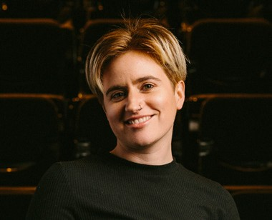
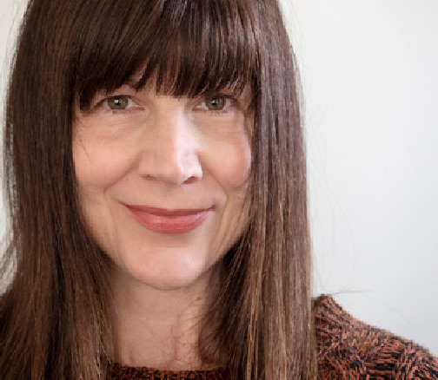
Sophia & Georgina

Sophia Constantine
Marketing and Communication Coordinator
e | sophia@lamama.com.au
Work days Monday - Thursday
Georgina Capper
Social Media & Content Coordinator
e | georgina@lamama.com.au
Work days Monday - Thursday

Introduction

Successful art marketing is essential in succeeding as an artist. In a nutshell marketing is about getting the right message to the right people, if people aren’t aware of your show they won’t come. We encourage you to consider marketing from the early stages of your development and not as an afterthought. This marketing pack is to inform you about what La Mama can offer in regards to marketing your show, what you are expected to do and some handy tips to encourage you to drive your own marketing plan.
What La Mama does for you:
- We have dedicated recourses to create individual sponsored posts for targeted promotion of all productions at La Mama on social media. As this will look different for all productions please organise a meeting with us to talk through options. And if you really want to delve deeper into the enigmatic world of social media check out our Social Media Tips on page 15 &16.
- We offer free hero images & production photography for all shows programmed at La Mama with professional photographer Darren Gill. See page 19 for more information on how to book your production photo session.
- In 2022 we will have a greater focus on Multimedia content creation as an essential part of our marketing strategy. This will include four seasonal launch videos created in-house. If you have any footage from a previous run of your production or from a development share it with us to include in the seasonal video. If not we will use the hero image you provide us to feature your production.
- We will create and distribute a seasonal media release that includes all shows in the program with a week or longer season. This will include an invitation to the opening night of your production for media, industry and funders. Find out more about this on page 17.

- Your production will be promoted through our weekly enews with 8,000 plus (and growing) active subscribers. Sign-up to our enews to keep in the loop and see your production featured.
- We will create a Facebook event as well as listings on What’s On Melbourne and Arts Hub for your production. More information about this on page 14.
- We will design, print and distribute a printed brochure that features your production. More information on page 9.
- We will create a web page for your production on our website. See page 13
for more information.
- We will design, print and organise digital distribution (via QR codes and Trybooking) of your show program. Go to page 20 to download the template.
What We Need From You:
- In order for us to do all the above for you we need you to provide us with all the relevant information via our Marketing 2022 form. You can read pages 6 - 8 to get an understanding of what information we need from you.
- We encourage you to think about creating video, audio and written content to promote your show. Where possible, we will support you with this but we need you to drive it. We can help you with editing, suggestions and getting your excellent content out into the world.
- The more information you can provide us with to assist in the visual storytelling of your show, the better. We can only spread a message from our end based on the information we have. Don’t keep us in the dark! Tag us in your social media posts, send through any pre-show radio or print interviews you get, send through your rehearsal snaps and anything else you think is a positive tool for us to create a buzz around your show.

Contents

SUBJECT PAGE
Hero Images 6
Free Photography: Hero Image 7
Production Details 8
Printed Brochure & E-flyer 9
Posters & Postcards 10
Multimedia Content Production 11
Designing Your Own Content 12
La Mama Website 13
Online Listings & Facebook Event 14
Social Media tips 15
La Mama Media Release 17
Generating Audience 18
Production Shots 19
Green Room Awards & Show Program 20

Hero Images
Submit: email sophia@lamama.com.au

A picture tells 1000 words
We really recommend you spend some time and dedicate some resources to creating your image.
Your image is the audience’s first interaction with your show. Think of it as the pre-prelude
to your show.
Here are some questions to consider when coming up with a concept and creating your image:
- What makes your work different?
- What is the tone of your work?
- What colours best represent your work?
- What is the best subject to represent your work?
TOP TIPS:
- Think about images that have captured your attention in the past – what is it about
that image that made it so compelling?
- You might also like to bounce ideas around with a ‘test audience’ (friends, family, your local baristas) to make sure your image will really turn heads.
- DO NOT put text on your image. Under any circumstances. The media can’t use it and it takes up precious space. Let your image speak for itself.
Ensure that you send alt text and image descriptions for each photo that you send us. Try to keep alt text to around 15-20 words. Your image description can expand on this, preferably to around 40 - 50 words.
We require 4 high quality images from you in the following format:
- 1 x Portrait image with no text
1122px width X 1630px height @ 300px/inch
- 1 x Landscape image with no text
2000px width X 1333px height @ 300px/inch
- 1 x Square image with no text
1080px x 1080px @72px/inch
- 1 x Web Program cover with no text
1920px width X 1080px height @ 72px/inch
These images can be the same image in the 4 formats or variety of different images. You can decide based on your creative goals. Please use your SHOW TITLE and PHOTOGRAPHERS name to name your image files.

Free Photography: Hero Image

CONTACT Sophia Constantine
If you need support with your show image, we have organised professional photographer, Darren Gill (www.instagram.com/darren.gill) who can take pictures for you. Put in a little prep work in terms of thinking about a concept and bring those ideas in with you. It’s tricky if you come in and haven’t got an idea of what you want. There is limited time and resources to come up with something on the spot. So do the work and you will have a fantastic result.

For specific dates please see email from Sophia.
See examples of Hero Images Darren has done for La Mama below.

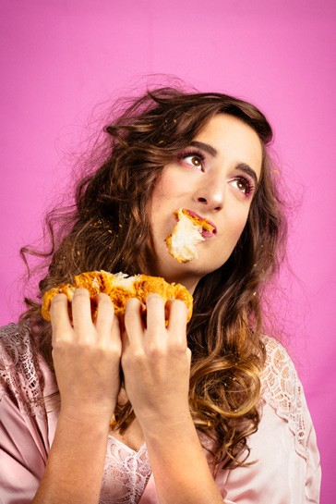
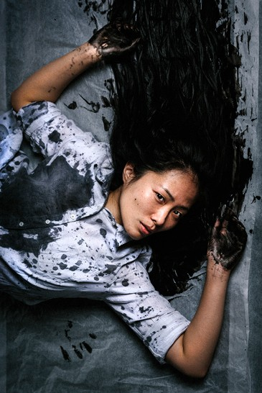
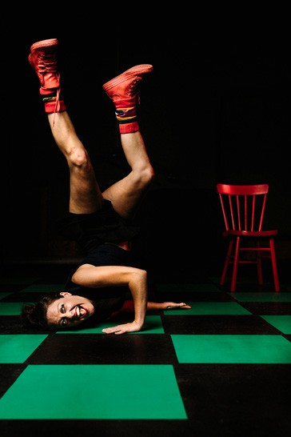

Production Details
Submit: via 2022 Marketing Form

We require the following details about your production submitted via the above form. This info will be used for the La Mama website, the brochure, our enews, social media content, online listings etc. Be sure to spend some time getting it right.
- Show Title
- Venue
- Tagline (distill the essence of your show in one sentence)
- Show blurb for brochure (80 words or less)
- Show credits
- Content warnings
- Media quote from works within the past 3 years
- Approximate running time
- Alt Text and Image Description
Keep us updated on any changes e.g. cast and crew changes. This way we can keep all your online marketing information up to date.
TOP TIPS FOR YOUR BLURB:
  - Keep things succinct and relevant.
  - Use concise language - short, sharp sentences.
  - Mention any relevant reviews or awards to give your work authority.
  - Address your reader, use words like ‘you’ instead of ‘audiences’ or ‘people’.

Printed Brocure & E-Flyer

CONTACT Adam Cass (design@lamama.com.au)
Your hero images and production details will be used to create La Mama’s season brochure. The brochure will be printed and distributed around Melbourne, stocked at our venue and sent to our postal mailing list as well as given to all the artists involved in the season (that means you!)
Please see examples of past La Mama Brochures HERE - In Winter & Spring 2021 we changed the format of our brochure to an A5 size. We will continue this format moving forward.
Upon your request (please contact design@lamama.com.au) we can create an e-flyer for you based on the information and images you provide for the brochure.
E-flyers are a great marketing tool to engage with people who don’t use social media. Sending the e-flyer to your friends, family and colleagues is yet another way for them to engage with your show (and hopefully book tickets). Remember to send the e-flyer to your creative team so they can send it out to their people!
E-flyer example:
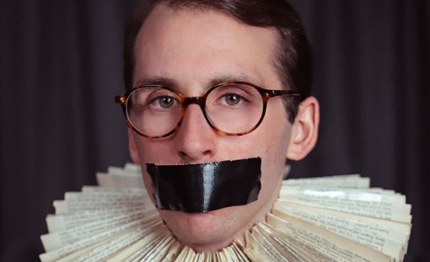
L a
M a m a
P r e s e n t s
a s p a r t o f m i d s u m m a
T H E W I L L T O
2 0 2 1
B E
A University Office, 1962: homosexuality is illegal. A lecturer is dismissed. His secret is out. Will he choose legacy or the law?
An award-winning solo show, exploring sexuality, society and shame, laced with the words of Shakespeare.
“Dazzlingly fresh and alive… a captivating performance… completely enthralling, and devastatingly romantic”
 – Adelaide Theatre Guide
“Compelling and must-see theatre” – Melbourne Observer
1 9 - 2 3 A p r i l 2 0 2 1
Mon & T ue 6.30pm, W ed 8.30pm, Thu 6.30pm, Fri 8.30pm L a M a m a C o u r t h o u s e , 3 4 9 D r u m m o n d S t , C a r l t o n B O O K I N G S 0 3 9 3 4 7 6 9 4 8 o r w w w . l a m a m a . c o m . a u

La Mama Theatre, 349 Drummond Street Carlton VIC 3053 Australia | info@lamama.com.au | +613 9347 6948 | www.lamama.com.au
La Mama is financially assisted by the Australian Government through the Australia Council – its arts funding and advisory body, Restart Investment to Sustain and Expand (RISE) Fund - an Australian Government initiative, the Victorian Government through Creative Victoria, and the City of Melbourne through the Arts and Creative Partnerships Program. We are grateful to all our philanthropic partners and donors, advocates, volunteers, audiences, artists and our entire community as we work towards the La Mama rebuild. Thank you!

Posters & Postcards

CONTACT Adam Cass
Using the image and information you provided, Adam can design and/or facilitate the printing of your postcards or additional posters. The design service is free but printing cost will be taken from your production budget.

Think about who your audience is and if postcards are the best way to reach them. Generally speaking we would advice that less is more when it comes to printed marketing materials. There are two reasons for this:

- Environmental impact – at La Mama we strive to reduce our impact on the planet and hope to encourage you to think about your practice and the way you market your work from a sustainable point of view.
- Social media marketing is shown to be more effective in terms of audience reach, engagement and cost efficiency. From audience data analysis in 2019 we discovered that on average less than 1% of audience have heard about shows via printed postcards.
But if you are dead set on getting your own printed materials we suggest: 5 - 10 posters and small run of around 50 - 100 postcards for the venue, other local cafes and to have in your bag for face-to-face marketing.
Postcard example:

LA MAMA PRESENTS
C A C T U S
Written by Madelaine Nunn

La Mama presents
c a c t u s
23 June - 4 July, 2021
A brutally funny and heartbreakingly honest coming of age story for anyone who is or ever has been… a teenager.

Winner of the ATYP R ebel Wilson Theatre maker Scholarship and shortlisted for the Rodney Seaborn Playwrights Award, Cactus was inspired by the ferocity of female friendship alongside the taboos and shame still present in female adolescence.

With a cracking all-female creative team, Cactus promises to be a beautifully wrought new Australian play full of insight and humour. This one is not to be missed!
Directed by Katie Cawthorne Performed by: Ayesha Harris-Westman, Lucy Rossen
Costume/ Set Design by Brynna Lowen
Lighting Design: Rachel Lee Sound Design: Daniella Esposito Stage Manager Claudia Howarth Produced by Madelaine Nunn
SEASON
23 June - 4 July
TIMES
Wed (preview) 6.30pm Thu (opening) 7.30pm Fri, Sat 7.30pm
Sun 4pm
VENUE
La Mama Courthouse, 349 Drummond St, Carlton
LENGTH
Approx. 75 minutes
TICKETS
$30 Adult
$20 Concession
BOOKINGS
03 9347 6948
or www.lamama.com.au
Image by: Darren Gill

La Mama is financially assisted by the Australian Government through the Australia Council – its arts funding and advisory body, Restart Investment to Sustain and Expand (RISE) Fund - an Australian Government initiative, the Victorian Government through Creative Victoria, and the City of Melbourne through the Arts and Creative Partnerships Program. We are grateful to all our philanthropic partners and donors, advocates, volunteers, audiences, artists and our entire community as we work towards the La Mama rebuild. Thank you!

Multimedia & Content Production

CONTACT Georgina Capper
La Mama’s Social Media & Content Coordinator will manage La Mama’s content, including support with editorial, video, audio and pictorial promotion of your production. Content creation should be an essential part of your marketing strategy, and you should try to diversify your offerings where possible, to include stills, text and video.
According to Social Media Week video consumption through mobile devices grows 100% per year, viewers retain 95% of a message when they watch it through a video, they also predict that in 2022 82% of audience web traffic will come from online video. With this growing evidence it is now a necessary inclusion in our marketing strategy to share your work dynamically within the digital space to La Mama’s ever-changing audience.
If you have any video content that supports the promotion of your production and you would like it to be considered for our social media platforms please email it to georgina@ lamama.com.au. Keep your videos to 15 seconds or less. Ensure your hook and important information is visible early as viewers can have short attention spans. Please accompany with a written transcript if your video contains any spoken language.
Georgina will sometimes create promotional videos around shows. She likes to have a bank of images, video and sound files to dip into where possible. If you have any audio that you’re using for your show (and please only audio that you have the rights to) feel free to send them her way in case she can use it for promotion.
Our audiences love learning about what is happening behind the scenes at La Mama - in the rehearsal room, back stage, wardrobe and workshop - especially in the lead-up to your Opening Night. Do make sure that you tag us on Instagram and Twitter if your post is relevant so that we know and can share, helping you reach new audiences.
You can contact our Social Media and Content Coordinator to discuss your content plans and strategies and she will help you execute them in line with La Mama’s style guide. However it is your responsibility to drive, plan and create your strategy and content. We can help you with tips and practical support along the way. And of course where possible we will share your content widely through our digital channels. Examples of support:
  - Assistance with video editing (including making sure the video adheres to our style guide)
  - Assistance with social media copy and setting up ads through La Mama channels
  - Support with media release copy.

Designing Your Own Content

CONTACT Sophia Constantine
If you are designing your own flyers, postcards, posters or videos, please ensure the following details are present:
□ La Mama presents
La Mama is the ’presenter’ of your production and so the correct wording for the title
will be:
La Mama presents [SHOW TITLE],
a [YOUR THEATRE COMPANY] production (if applicable)
- Show Title
- Season Dates
- Season Times
- Venue Information
La Mama Courthouse, 349 Drummond Street, Carlton
or
La Mama HQ, 205 Faraday Street, Carlton
- Ticket Prices (for primary seasons)
$30 Full | $20 Concession
- Booking Information
03 9347 6948 or www.lamama.com.au
- La Mama and Funding Body Logos
Download Logos Here
Please note:
All self-designed marketing materials need to be proofed by Sophia before going to print or published online. This has nothing to do with your autonomy in designing things with your own style, it is about logo placement and appropriate acknowledgment of our funders.
Example of self designed flyer:
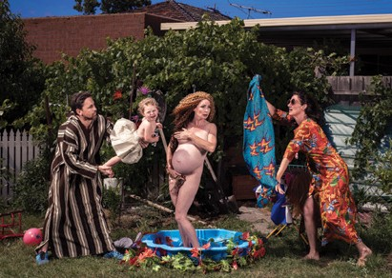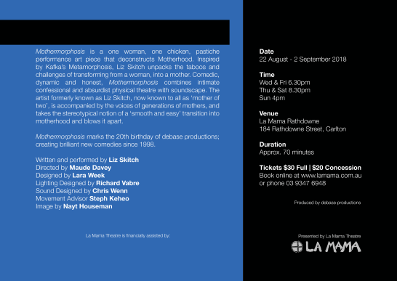

La Mama Website

CONTACT Sophia Constantine
We will use your hero images and production details to create your show page on our La Mama website. Please go to our website at https://lamama.com.au/whats-on/ to see more examples. Sophia will send you a unpublished link to your web page to look over before the page goes live (please refer to email from Sophia to see the web launch date for your season). We can edit the web page for you at anytime, so if anything changes (cast, crew etc.) please let the marketing team know.
Example of a web page:
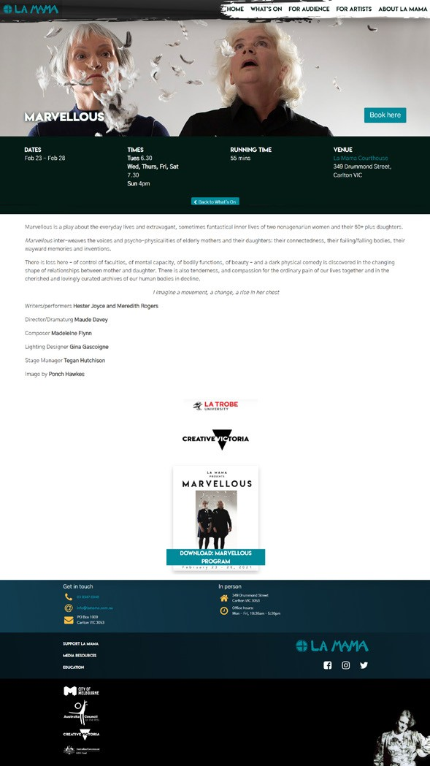

Online Listings & Facebook

CONTACT Georgina Capper
Online listings are a great tool to get people outside of your direct networks along to your show. Facebook events have the added bonus of allowing you to converse with a chunk of your audience.
ONLINE LISTING
La Mama will create events for your production on the following websites:
- What’s On Melbourne (from Sept 2020 - Sept 2021 our data shows 11.2% of audience traffic to our website has come th ough What’s On Melbourne listings. We suspect this would be higher if it weren’t for the pandemic closures)
- Arts Hub
- Choose Art (This is appropriate if your show has additional accessible performances
e.g. AUSLAN, Audio Description etc.)
FACEBOOK EVENT
La Mama will create a Facebook event for your show and share it on our La Mama Facebook page. Once this has been created we will make one of your team the Admin. From then on, this page is your responsibility to manage. If you don’t have your own Facebook page (business or artist page) that we can add as a co-host for your event, please add us as a friend from your personal account: Mktg LaMama for Facebook administrative purposes: https://www.facebook.com/mktg.lamama/ Please email Georgina a list of the names of anyone wishing to be added as Admin of your Event page. If you prefer to create your own Facebook event, please let us know and add La Mama as admin to co-host the event.
We provide financial support for an ad / sponsored social media post for your production via La Mama’s Facebook. Please liaise with Georgina on the best content and timing for your post.
La Mama Theatre Facebook page: https://www.facebook.com/lamama.theatre/
Don’t forget to tag @lamama.theatre (FB) @lamamatheatre (Instagram) @LaMamaTheatre (Twitter) when posting about your show.
MORE ONLINE PROMOTION YOU CAN DO
You can create additional online event listings for free with other websites. Here are a couple of free listing sites to get you started:
- Weekend Notes Melbourne: https://www.weekendnotes.com/melbourne/
- All Events Melbourne: https://allevents.in/melbourne#
- Broadway World: https://www.broadwayworld.com/australia-nz/

Social Media Tips

CONTACT Georgina Capper
Social media is a powerful tool. Use it! In the marketing form there is space to provide us with a list of your Facebook/Instagram/Twitter handles for online engagement so we can tag you and put your information on your web page. Please make sure you fill in this information with all members of your team that are willing to be tagged.

Remember to share any content/articles/interviews with us so we can help you promote
things such as pre-show media coverage, promo videos etc.

SOCIAL MEDIA AT A GLANCE
Be strategic with your content: It’s one thing to post for the sake of posting, it’s another to
have a strategy that justifies your content. Before embarking on any social media campaign, ask yourself, ‘Why am I even doing this?’ Is it to generate ticket sales? Is it to gain exposure? Or to connect with your audience? Each of these motives will require different strategies to be successful.

Be personal in your approach: People care as much about the “who” as the “what”. Social media research shows that posts written in the first person, with people in the photos get significantly more likes and shares. This means use ‘I/We’ to make posts even more compelling. Social media is just that - social. Those participating want to create authentic relationships with real people. You will be surprised at how your followers will embrace your authentic voice.

Be consistent with your posting: In the social media world, more posts equals more likes and more shares. It may seem obvious, but it’s true. However, if it seems too easy to be the whole truth, you are right. There’s a caveat. If you start posting awesome photos and videos about your production ten times a day, and all of a sudden you take a break from posting in production week and your feed goes blank, your audience will notice. Not only will they notice, but this inconsistency can result in long-term detrimental impacts to your total likes and shares. Not to mention, most social algorithms, most notably Facebook, look unfavourably on a lack of consistency. You can keep your posting content all through production week (arguably the busiest time) with tools such as Hootsuite that allow you to schedule posts in advance.

Be analytical in your journey: “But, I didn’t become an artist to look at numbers!” That’s probably accurate. However, what matters is that analytics can give you huge insights into your social media strategies, and optimise what you’re doing so you can spend less time on social media.

Handy Resources: When we talk about social media marketing you can’t go past the dreaded topic of Social Media Algorithms. We have compiled some hot tips to boost your algorithms and get more reach. Available HERE.

Producer, April Brenner from BCauseARTS, shared a fantastic PR timeline and social media schedule spreadsheet with us when working on a show. With her permission we are sharing it with you here. Feel free to use it and adapt it to your needs.

Social media is ever evolving so we recommend taking some time to research, check out your analytics and experiment with what works for your followers.

La Mama Media Release

CONTACT Sophia Constantine
La Mama receives invaluable support from numerous local media outlets. With over 100 productions per year, our challenge is to communicate everything we present without completely flooding the inboxes of those that support us. For this reason, we are transitioning to a seasonal media release model as outlined in our 2022 - 2025 Marketing and Communication Strategy. This means we will create a media release that will incorporate information about all shows with a 1 - 2 week season in one media release per season (Summer, Autumn, Winter and Spring). We will draw information from the marketing materials you supply as well as in consultation with our Artistic Director and Creative Producer. Please see an example here from our Summer 2022 media release. We will send the media release to media, industry and funders inviting them to the opening night of all shows with a 1 - 2 week season. We will send a reminder half way through the season to prompt people to RSVP. Sophia manages the RSVP responses and she will book them into the Trybooking system in which you can monitor with your Trybooking link.
OPENING NIGHT
La Mama will hold 15 - 20 tickets from your opening night capacity for media, industry, funders and other stakeholders. We will automatically release any unused tickets 2 weeks before your opening night. If you have special guests you want at your opening night we recommend you book them early and if that isn’t possible you can hold tickets under your name until you have confirmed opening night special guests. We can change the names for you once they are confirmed.
INDIVIDUAL MEDIA RELEASE
An individual media release is a good tool to use when promoting your work to the media. La Mama can design a media release on your behalf and you can distribute it to your contacts. If you would like us to design a media release for you please send your copy to Sophia 6 weeks before your show opens. We will also add your media release to the Media Resources session of our website. If you want to design your own media release please share it with us before you send it out so we can make sure logos are correct and so we can utilise the copy in our marketing campaign across our digital platforms. For some handy tips on writing a media release and following up with media please see HERE.

MEDIA CONTACTS
We can provide you with a list of our media contacts that have given us permission to give their information to you. If you would like this list for your PR campaign please contact Sophia.

Generating Audience

CONTACT Sophia & Georgina
Please be aware that audience generation is a shared responsibility between you, your team, and all of us here at La Mama. Whilst we expect you to do your best to get people along to your show, we won’t be upset if the numbers end up a little leaner than expected. Typically shows tend to fill up towards the end of the season. Shows following the opening night can be a bit of a struggle. Let your cast and crew know to use up any complimentary tickets over the first few nights.
We Recommend
- Closely monitor the Event Summary on Trybooking to identify potential nights that need extra help.
- Don’t forget to promote yourself.
- Ensure that everyone involved has the correct promotional material at their disposal
- this will make it easier to share content on social media.
- We will monitor the response to your opening night invitation and bookings. If this is low, we will follow up with you to see if you would like to set up any special booking codes or run giveaways for any particular nights.
- Consider any groups, schools or organisations that you might be prepared to send a discounted ticket offer.
- Take photos & videos during your rehearsals for building online engagement. This digital content will give your social media followers more information about your show and generate interest to come.
TICKET GIVEAWAYS
We have great relationships with the student theatre departments at Melbourne University, La Trobe University and Monash University. We also have relationships with other local arts orgs that will share giveaways. If you would like to do a giveaway for your show let Georgina know. We can also put giveaways in our Enews, which is sent out weekly on a Tuesday. Please let us know if you would like to do this. Doing ticket giveaways can be a great strategy to generate interest for your show (those who don’t win the double pass may still book anyway!). It is also a way to get more bums on seats and conversation buzzing around the work to hopefully pull in more paying punters. If your sales are looking a little leaner than expected we will reach out to you about giveaways.

Production Shots
FREE PHOTOGRAPHY: Production Shots

CONTACT Sophia Constantine
It is required that you have someone take production shots during your dress rehearsal. These production shots will be used for media reviews and social media posts. Some media outlets will not accept images for their review unless they have been taken during the current production. If you need support for your production shots, we have organised professional photographer, Darren Gill who can take your pictures at no cost to you! If you would like to use this free service, please get in touch with Sophia 6 weeks out from your show to let her know the time and date of your final dress rehearsal in the space and she will book Darren in. Please note Darren works as a freelance photographer so please book in with Sophia early to make sure you are not disappointed.

Please name your production shots:
ShowTitle_People-in-image-LtoR_PhotographybyNAME.jpg

See examples below of some of Darren’s past production shots at La Mama:
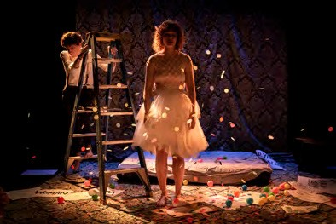
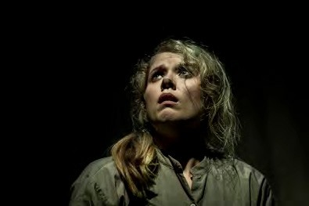

Green Room Awards
The Green Room Awards are Melbourne’s leading performing arts awards that recognise world- class cabaret, dance, musical theatre, opera, theatre and alternative/hybrid performance productions that grace Melbourne’s stage each year. Panels of industry professionals who specialise in the different disciplines are responsible for deciding the nominees and recipients. Because of this industry involvement, a Green Room Award is a highly respected accolade for all performing and technical artists.
We encourage you to register your production with the Green Room Awards. There is a
$16.50 registration fee for each production that can be paid by direct deposit. You can include Sophia’s details as your ticketing contact and she will manage booking requests. Industry Panels do their very best to get to all registered productions, however registering your production does not automatically guarantee attendance by the Green Room Awards panel members. Registrations should be submitted at least three weeks prior to your first performance to increase the likelihood of panel attendance.
Registration link: https://www.greenroom.org.au/register/
NOTE: You are only ever eligible for a production ONCE.
Show Program

CONTACT Sophia Constantine
La Mama will design and print your show program in black and white A5 for audience every night. We will also print an accessible large print version. Your program will also be available online on our website as a downloadable PDF and plain text Word Doc.
We will require the following details for your show program one week before your show opens:
- Show Title.
- Updated show credits (including photography credits).
- Creator and Director’s Notes (300 words max).
- Biographies for everyone involved (around 75 words each).
- Acknowledgments / Thank you’s.
- High Resolution logos (if applicable).
Please fill in the show program template and send it to Sophia one week before your show opens.
Note:
- DO NOT send bios individually.
- Use your show title to name your document (eg. SHOWNAME_program.doc).
- Where possible, keep the entire document under 900 words approx.

