*Artemis: Utter Mess*

# Relaxed Performance & Accessibility Resource Pack Prepared by Artemis Munoz

VENUE: La Mama HQ

205 Faraday St, Carlton

DATES:

May 17th - 22nd 2022.

RUN TIME:  
Approx. 55 minutes no interval

Relaxed Performance & Accessibility Pack

***Artemis: Utter Mess* | La Mama Autumn Season 2022**

**CONTENTS**

* Breakdown of Access Measures: Page 3
* Travelling to and accessing the venue: Page 4
* Relaxed Performances and COVID-19: Page 5
* Contact Us: Page 5
* Venue images and description: Page 6
* Stage images and description: Page 13
* Performer images and show description: Page 15
* Content Warnings: Page 16

ACCESS MEASURES OVERVIEW

Relaxed Performance Principles

FULL LA MAMA HQ SEASON  
Softened sensory profiles  
House lights on at low level  
Anytime access to quiet space  
Audience encouraged to move/stim/make noise during performance

SUNDAY 22ND  
Audience capacity capped at 75%

Auslan Interpreting

THURSDAY MAY 19TH  
SATURDAY MAY 21st  
by Mac Gordon

ONLINE VERSION  
by Linda D’Ornay

Audio Description

FULL LA MAMA HQ SEASON  
Integrated into work

ONLINE VERSION  
By Nilgun Guven

Step-free Access

FULL LA MAMA HQ SEASON  
Theatre (Doorway 1m wide)  
Courtyard  
Bathrooms  
Quiet Space

TRAVELLING TO & ACCESSING THE VENUE

La Mama HQ is close to the corner of Lygon and Faraday Streets - between the Grill’d and Shakahari Restaurants. It is very close to the tram stop *Lygon St/Elgin St* (Trams 1 and 6) and a short distance from the tram stop *Melbourne University/Swanston St #1*(Trams 1, 3/3a, 5, 6, 16, 64, 67 and 72).

The streets surrounding La Mama can be busy in terms of both cars and foot traffic - especially Lygon street. For performances on Tuesday the 17th through to Saturday the 21st, at time of arrival for the show you can expect the sun to be set. This means that La Mama’s frontage and courtyard will be lit up with artificial lights in a warm tone. On Sunday the 22nd you will enter and exit the theatre to natural light.

You access La Mama by walking through the opening between the corrugated metal and the wooden door - which will be open shortly before each session of the show. To access La Mama’s courtyard you can either take the stairs or the lift for those who require no step access.

The courtyard serves as the venue’s foyer and there is a bar available for snacks and beverages. This area is outdoors and so may be impacted by weather on the day. There are both flooding lights and string lights in this area and it may get a bit busy as we get close to opening doors to the theatre. In this area you will get your name ticked off La Mama’s list and be given a raffle ticket which is your number for La Mama’s door prize.

From here you will also be able to gain access to the quiet space (to the immediate left of the courtyard entrance), the toilets (past and to the left of the bar and behind the tall staircase) and the theatre itself (straight ahead at the far end of the courtyard.

RELAXED PERFORMANCES AND COVID-19

* Because we are aware that masks can pose a sensory issue to some, wearing one is not mandatory.
* We still ask that those without an access need relating to masks wear one for the duration of the show.
* Due to COVID-19 risks, we are unable to provide communal stim toys or tools such as headphones and ear-muffs in our quiet space.
* Audiences are highly encouraged to bring and use their own stim toys, headphones or anything else that will help with self-regulating.
* The artist is highly aware of the disproportionate effects of the pandemic on the disabled community and encourages those who feel unsafe attending in person to engage with the online version of this work.
* The performer, Artemis Munoz will be mask-less for the duration of the performance as is necessary for them to perform the work. They will put on a mask afterwards to chat to people who chose to remain in the courtyard after the show.

CONTACT US

If you have any questions or feedback about the auslan interpreted or relaxed performance, or about other accessibility concerns, please contact Artemis (Producer of *Artemis: Utter Mess*) at [artemismunoz@gmail.com](mailto:artemismunoz@gmail.com) or Myf (La Mama’s Outreach and Engagement Producer) at [myf@lamama.com.au](mailto:myf@lamama.com.au). You can also contact [info@lamama.com.au](mailto:info@lamama.com.au) or (03) 9347 6948 to notify La Mama of access requirements particular to your circumstance or not yet catered to by this production.

VENUE IMAGES AND DESCRIPTION

This is the front of La Mama, with a car parked outside. The venue is near the corner of Lygon and Faraday streets between the restaurants Shakahari and Grill’d. Pass to the right of this grey brick building to enter.

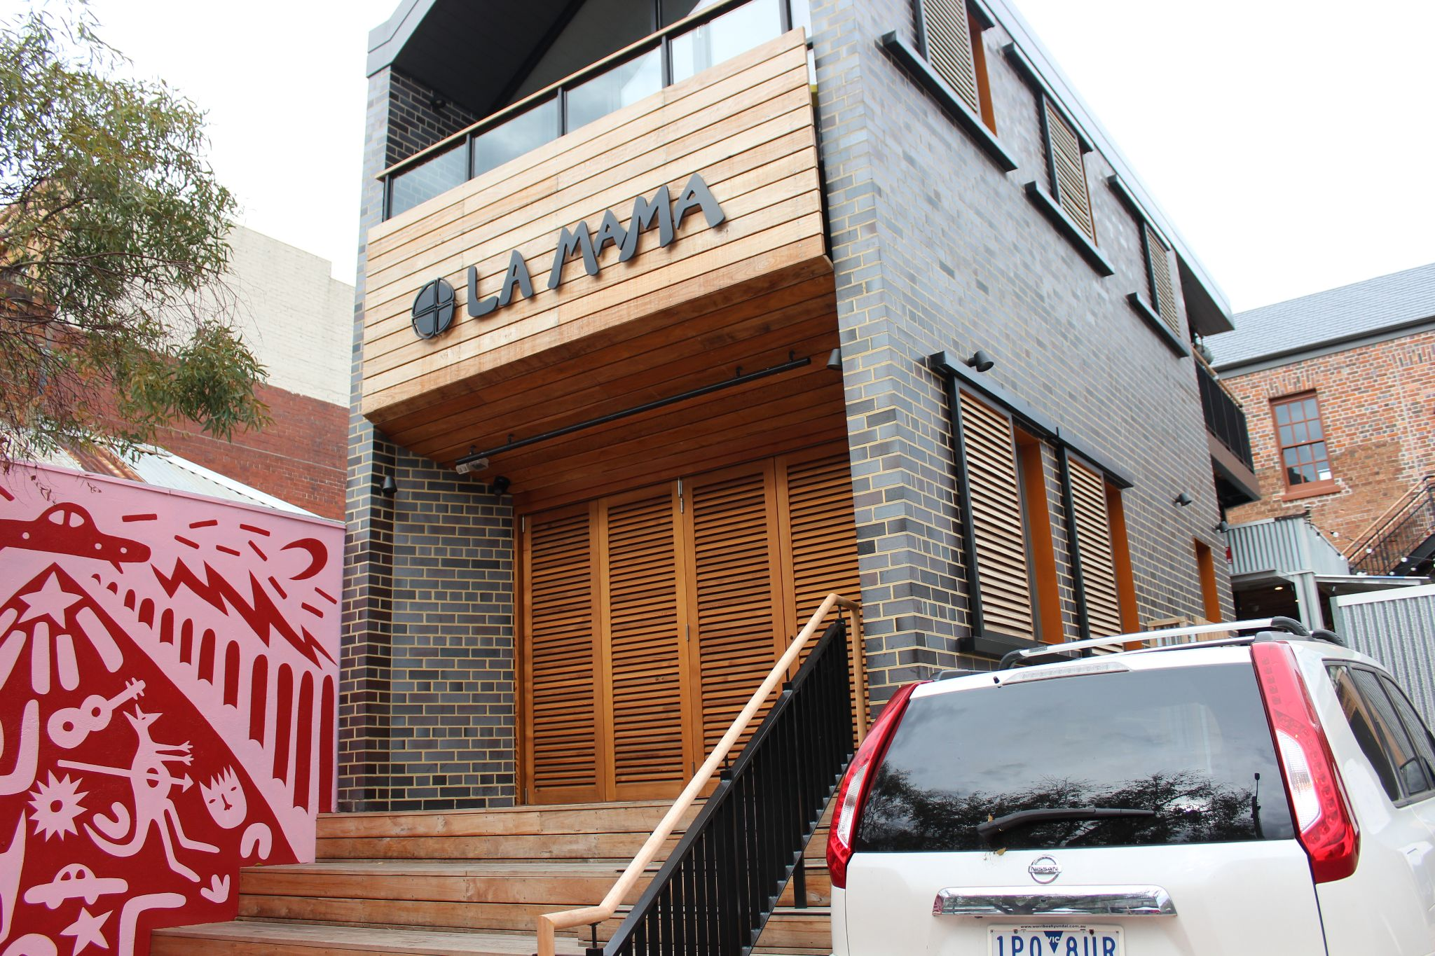

The entrance to the courtyard is through this door. It will be open like this when the audience is able to access the venue for the show. If it is closed please wait until a member of the front of house team opens the door.

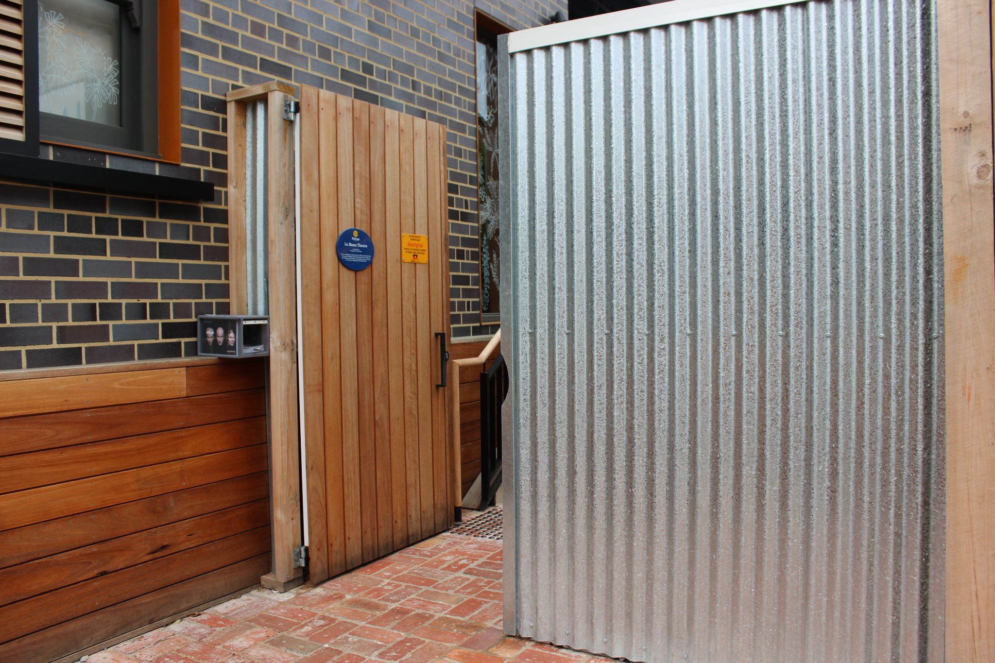

Once you have entered you can take either the stairs or the lift up to the courtyard.

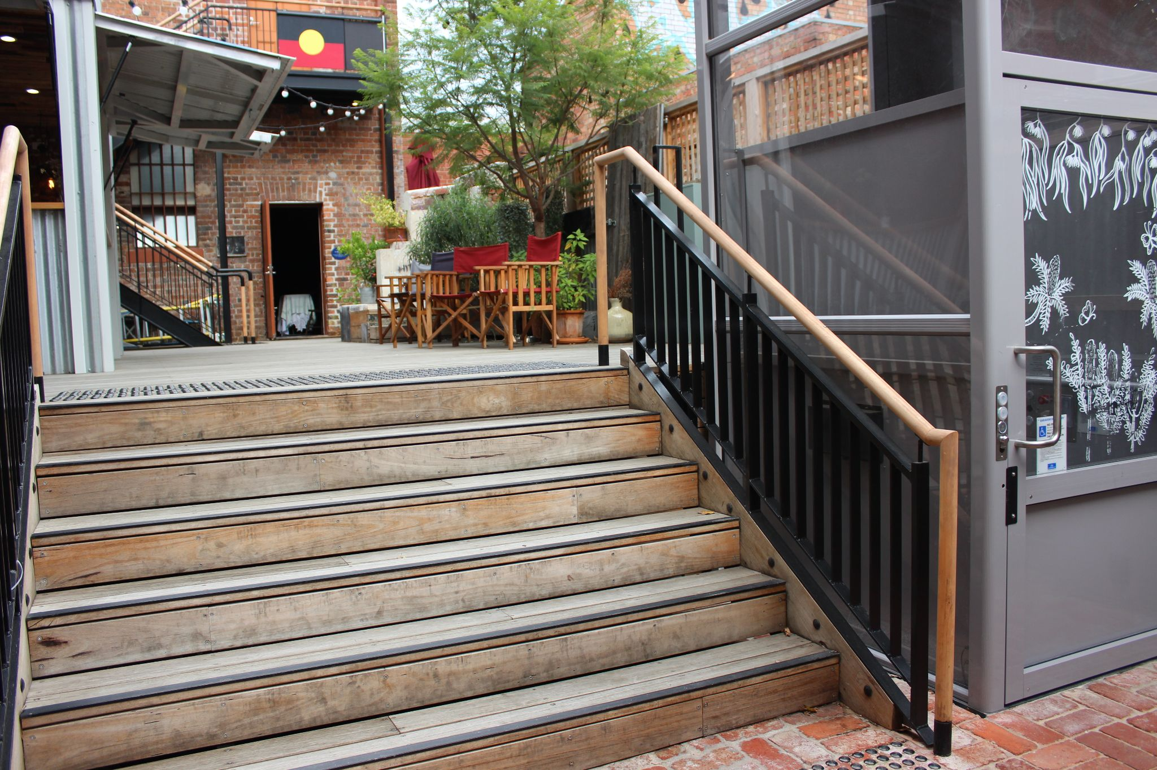

To operate the lift, hold the directional arrows to make sure it’s at floor level before stepping in.

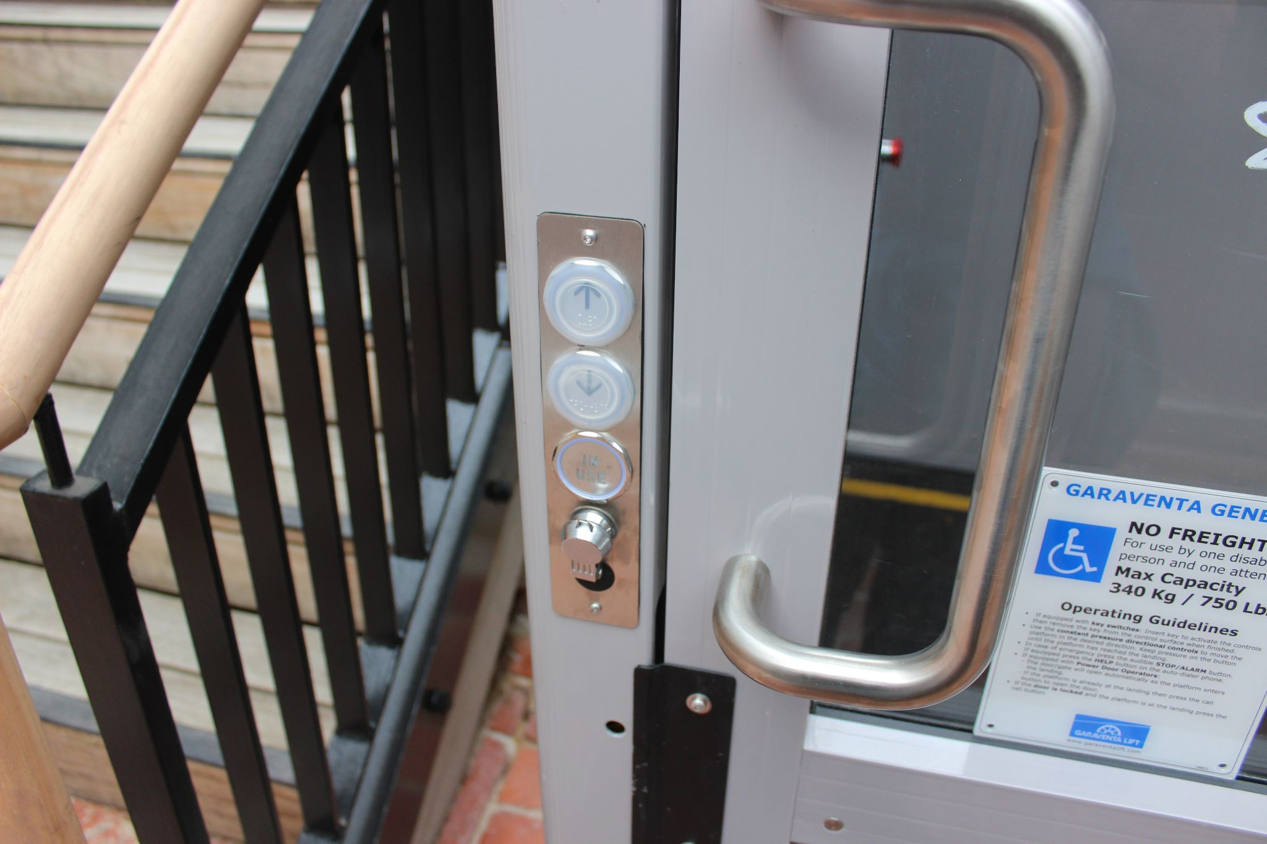

Then when inside hold the arrows down until the lift stops moving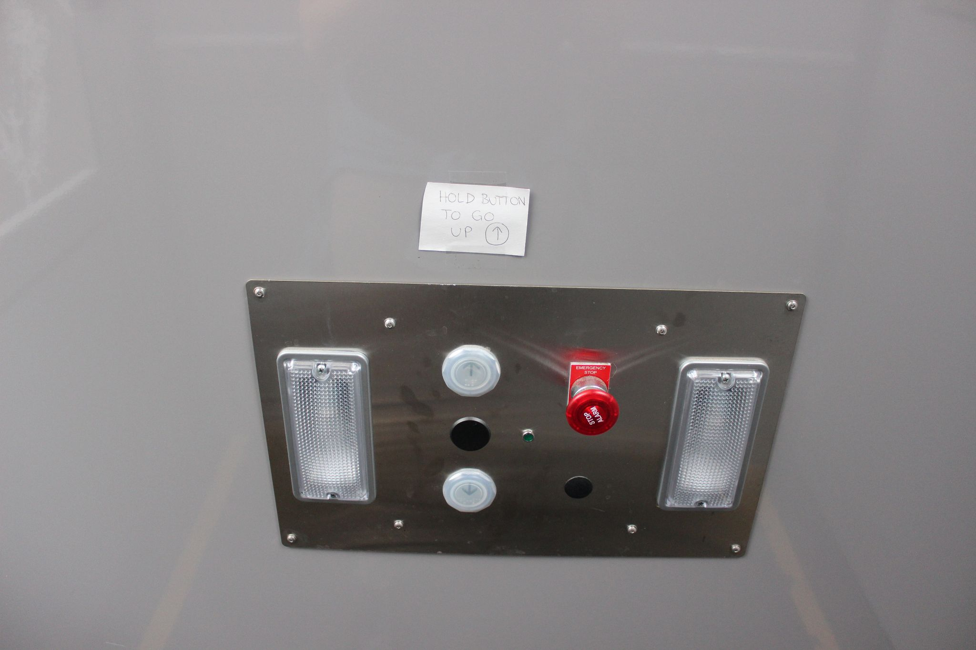

You can then exit by pushing the door outwards

To the direct left of the entrance staircase and lift, there is a little orange and grey alcove.

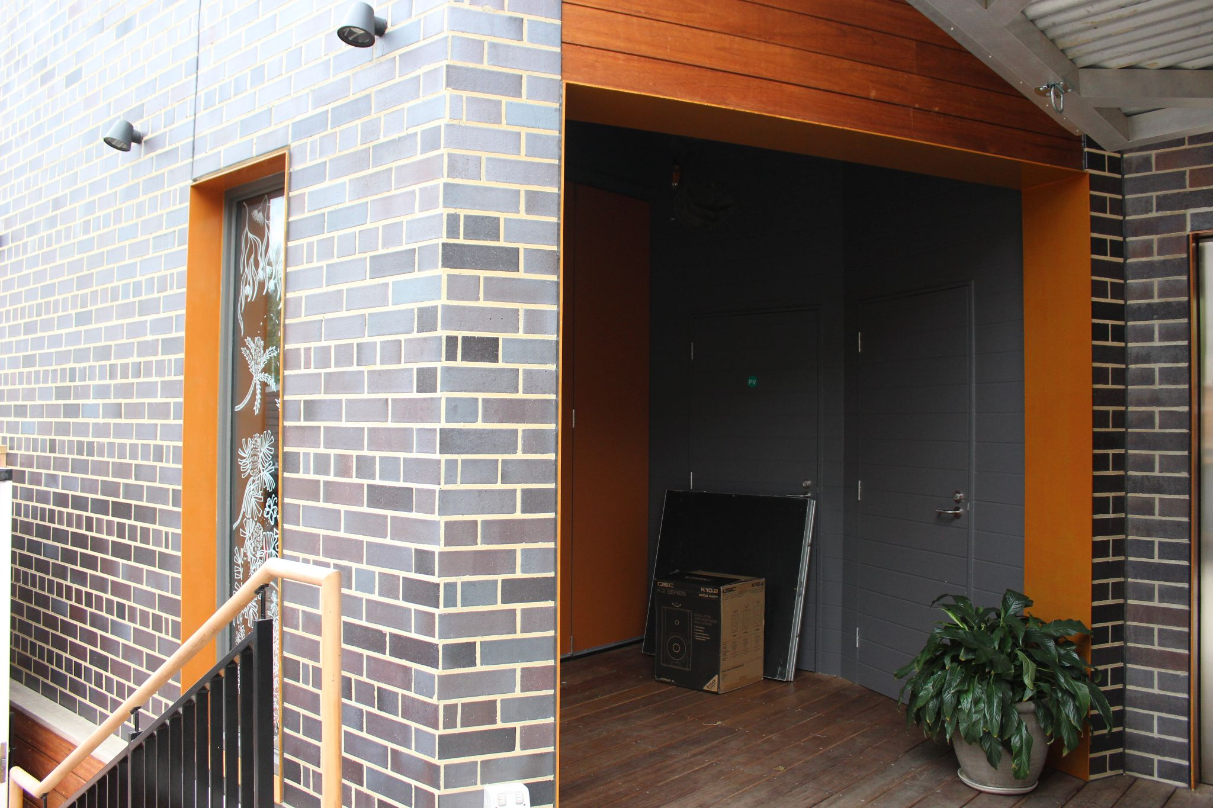  
Continuing through there, you will reach the door to the quiet space.

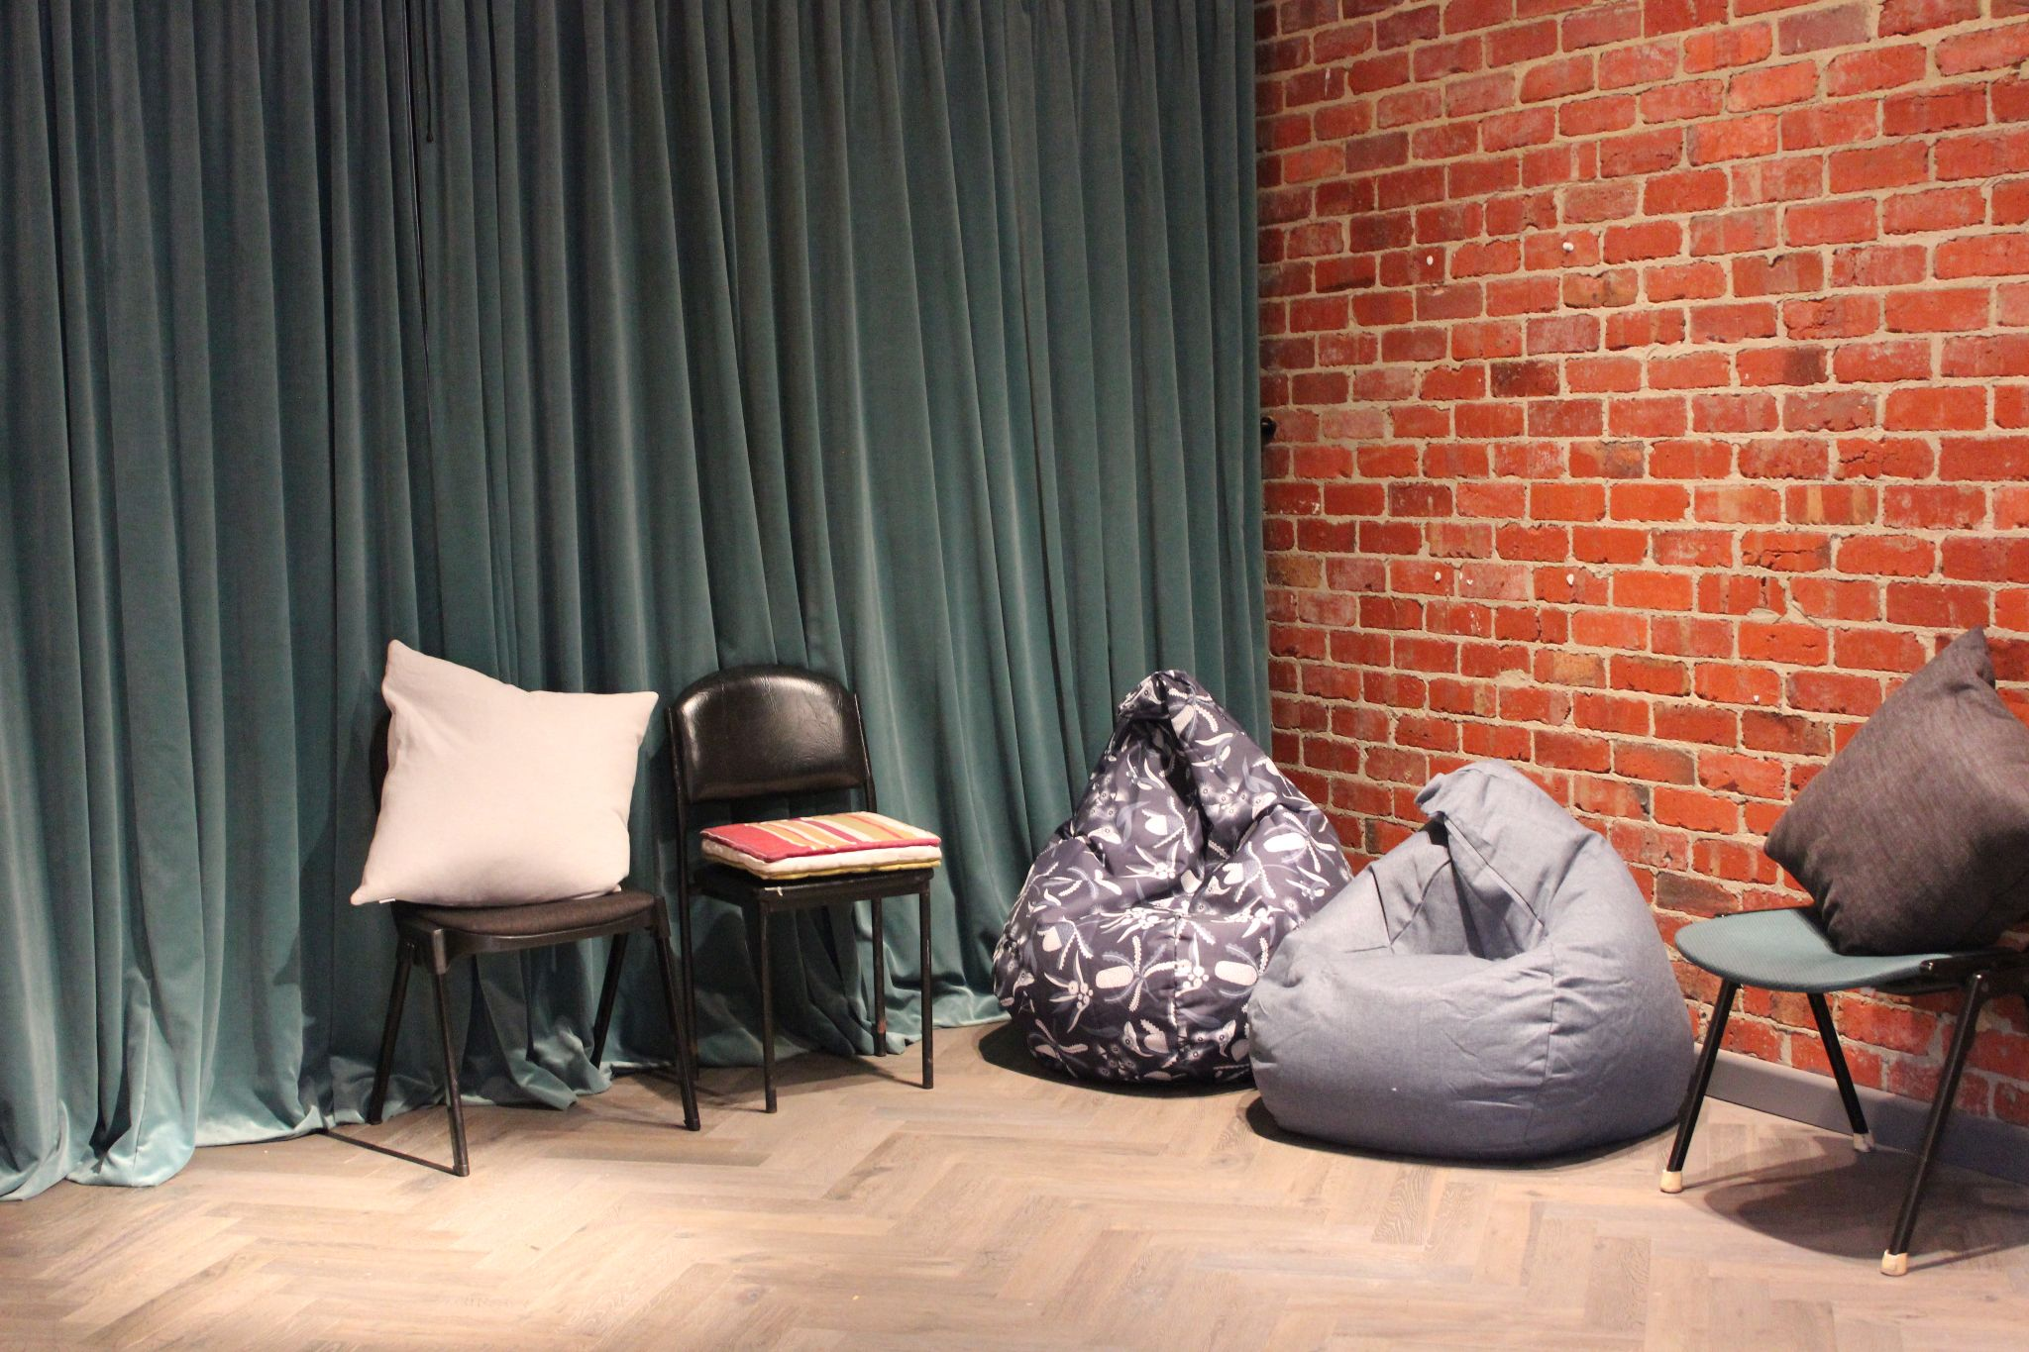

Feel free to come and go or adapt the space to your sensory needs as much as you like.

Back in the courtyard you can also access the bar. Here you can speak to La Mama staff about the show, access the program, get your name ticked off the list and get snacks or drinks.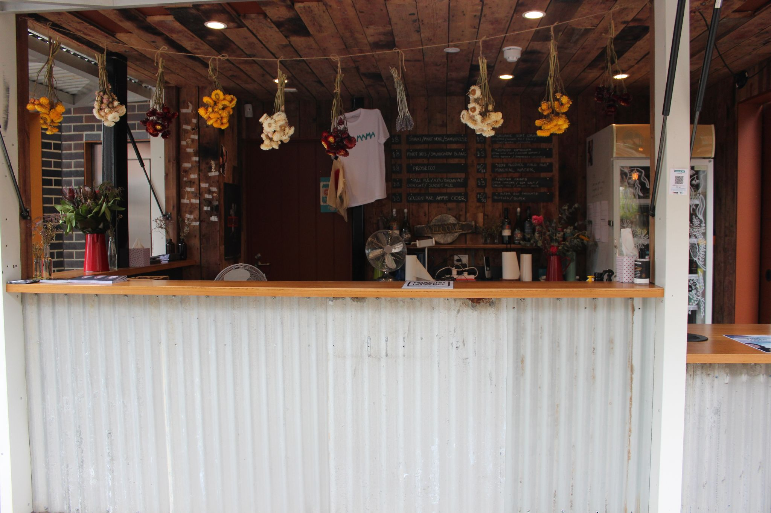

There’s also a drinks station where you can get complimentary tea, coffee, hot chocolate and water.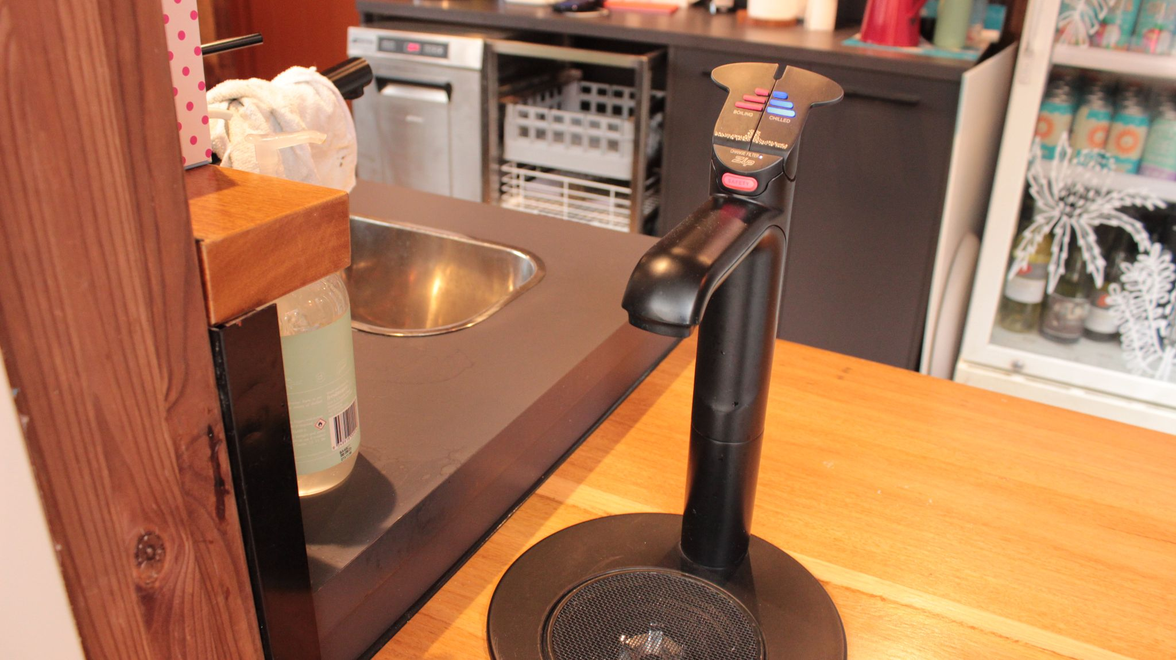

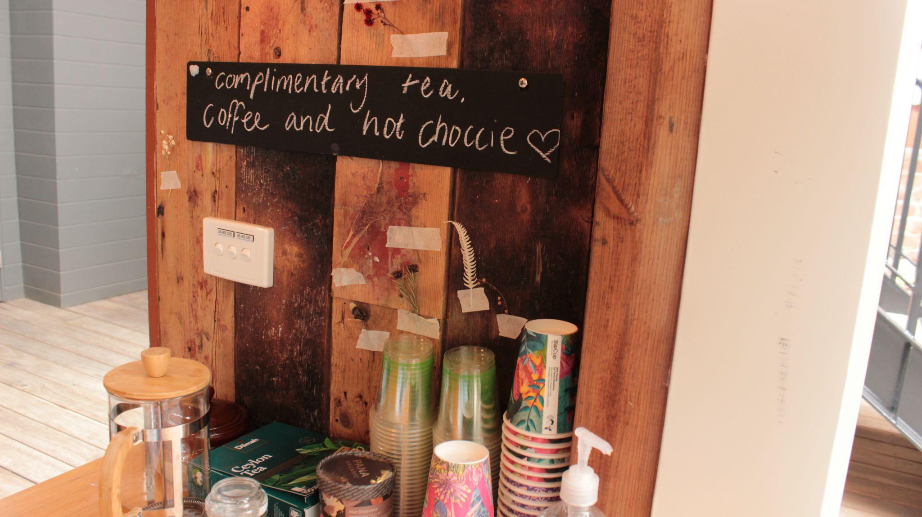

To the right of the bar, near the large staircase to the offices above, you’ll find the toilets. All genders are welcome to use either toilet but the one on the left, nearest to the bar is the accessible bathroom.

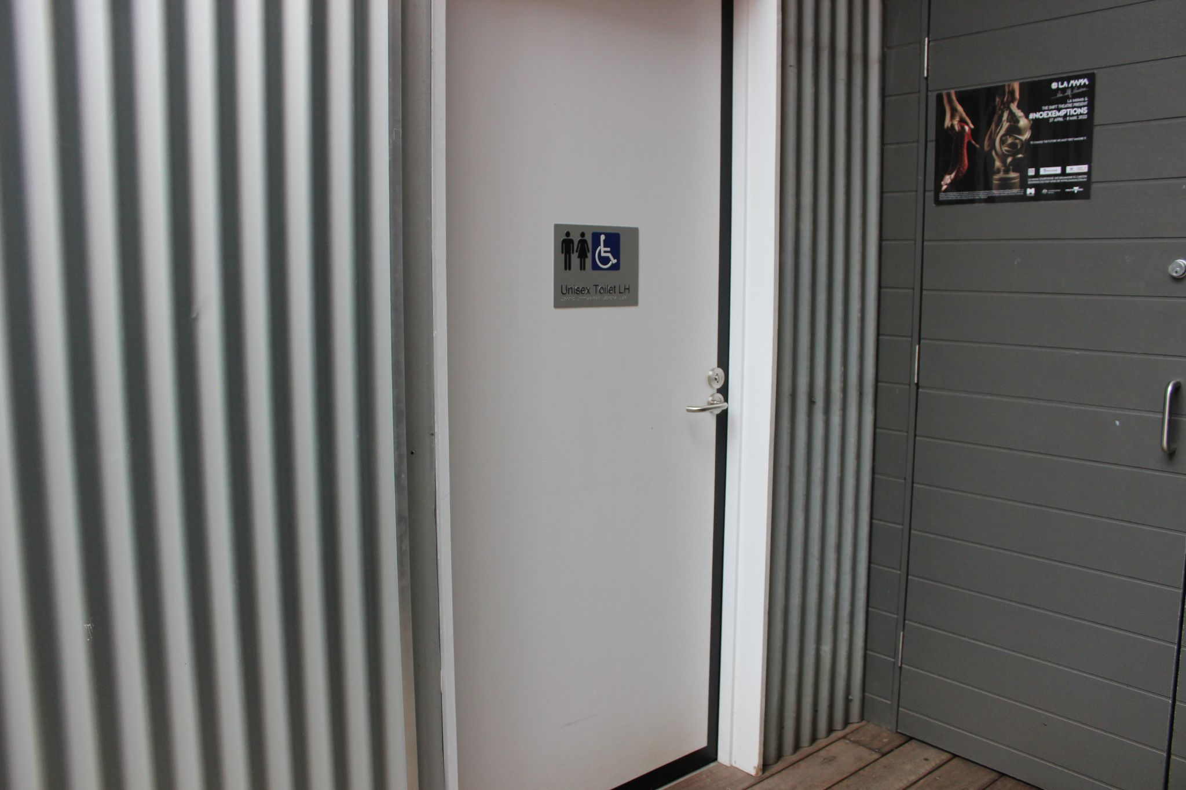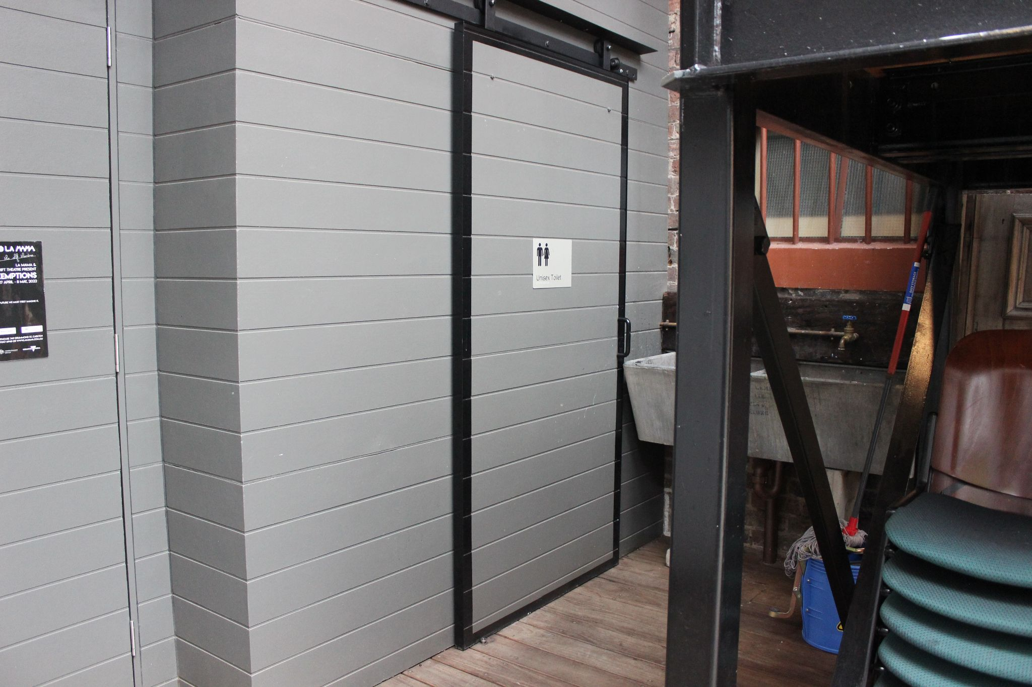

At the far end of the venue is the door to the theatre itself. La Mama’s front of house team will let you know when you are able to come inside.

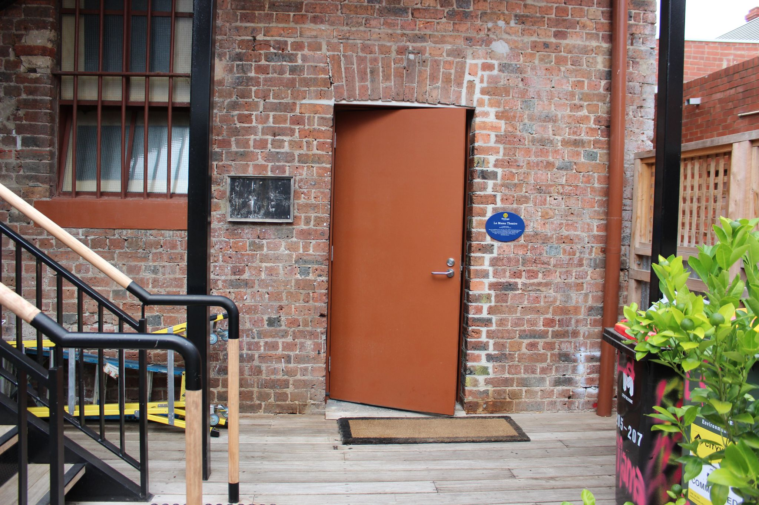

INSIDE THE THEATRE:

To your left after entering is the seating bank where you will be seated for the performance. It looks something like this, though the lighting will be a little different when you enter.

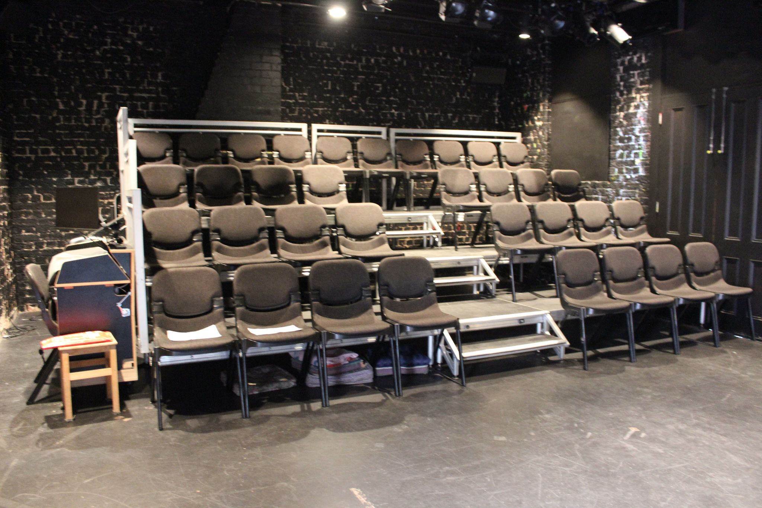

Seats are not allocated, you can go and pick any seat you like. If you have an access requirement for a particular seat La Mama is happy to ensure it remains reserved for you. Please contact the team via [info@lamama.com.au](mailto:info@lamama.com.au) or (03) 9347 6948 to arrange this.

After you are seated, La Mama’s staff will draw the raffle and the show will begin.

The stage will be decorated with cardboard boxes which will have various descriptive words written on them. These will be collapsed and set aside over the course of the show. At the start of the show the view of the audience will be something like this:  
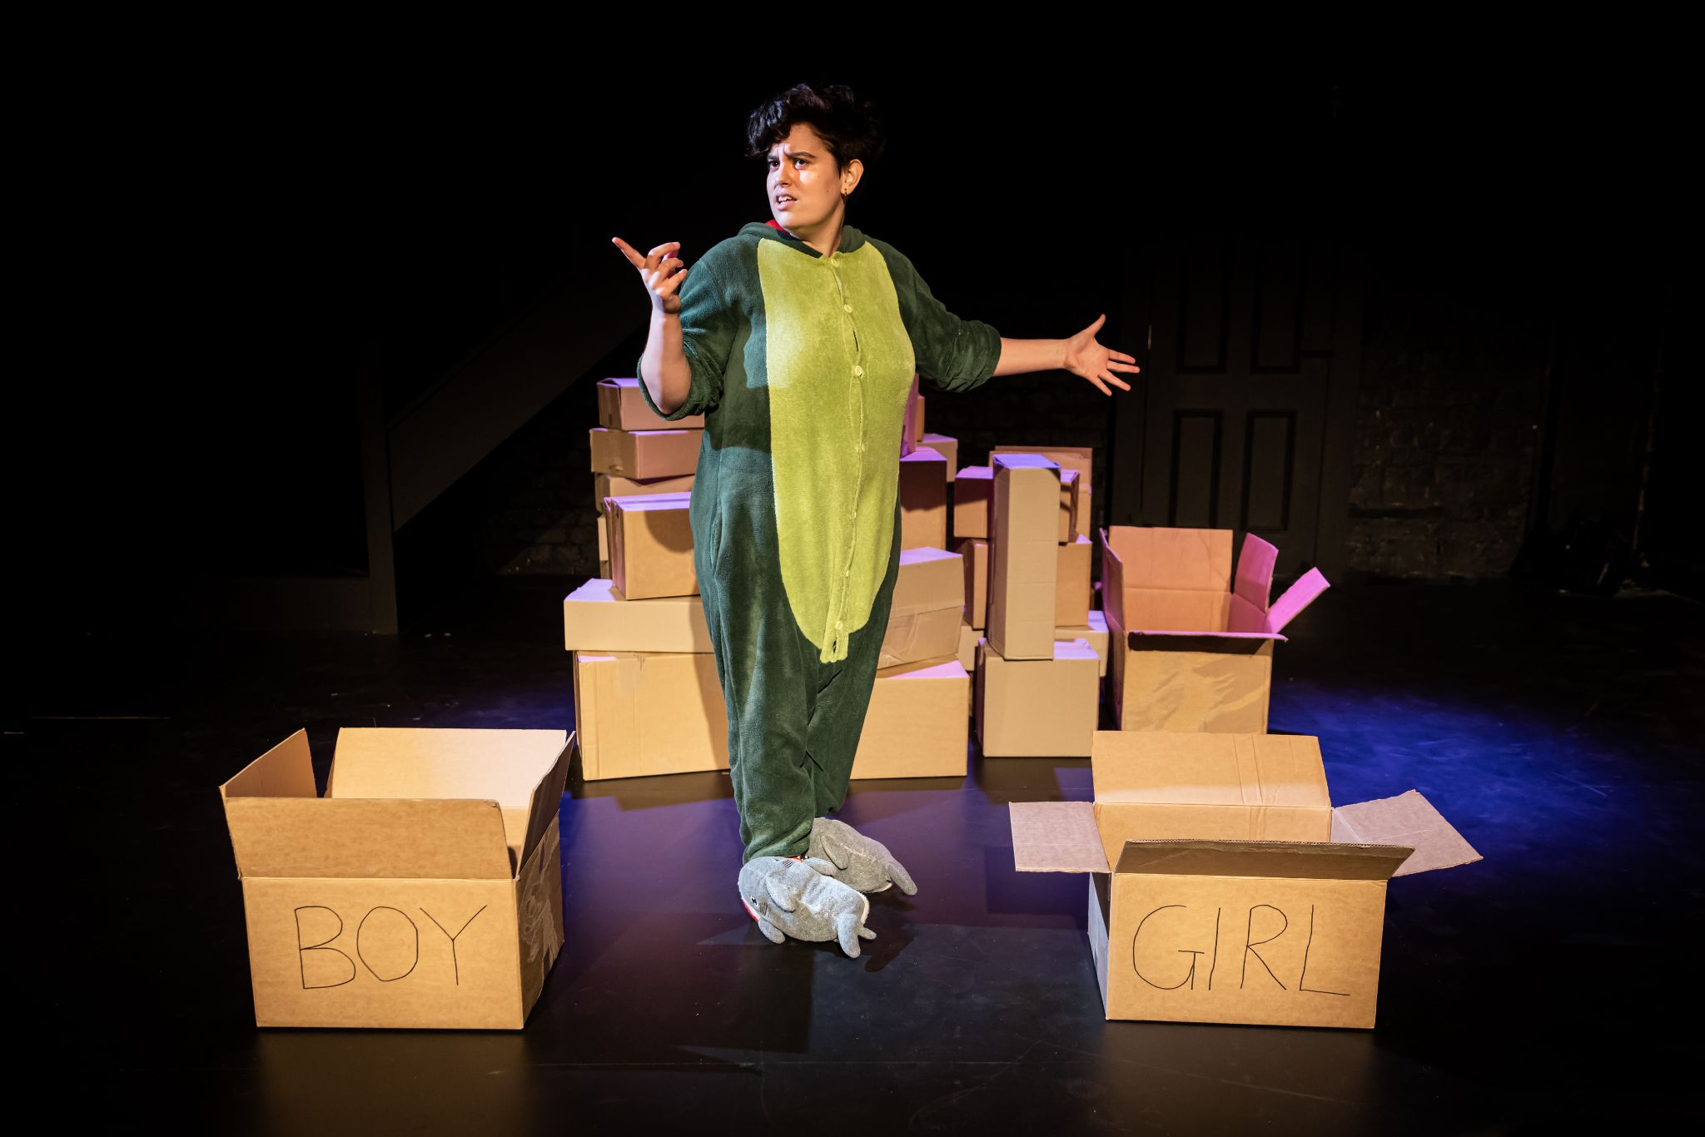

The entire performance will be conducted from the stage, no audience members will be singled out for input during the show, however Artemis will directly address the audience for the majority of the performance. There is no “fourth wall” in this show.

PERFORMER IMAGES AND SHOW DESCRIPTION:

Artemis Munoz



Artemis Munoz (they/them) is the writer, director and main performer of the show *Artemis: Utter Mess*.

The show features 9 songs and other spoken stories and anecdotes which will all be performed by Artemis. The story of the show is about their experiences discovering and learning to understand their identities as a trans, nonbinary, ace (asexual), neurodivergent, and multiracial person.

It is for the most part light-hearted in tone and features a lot of comedy, although the content can veer into some heavier areas as Artemis sings and tells the audience about how messy it is to have so many intersecting identities and to exist in a world that may not have been built with you in mind. Ultimately, the show is warm and ends on a positive note.

CONTENT WARNINGS:

* Discussion/Exploration of Queerphobia (specifically aphobia and transphobia)
* Discussion/Exploration of Externally Imposed Boundaries
* Discussion/Exploration of Structural Inequity
* Discussion/Exploration of Cultural Identity
* Discussion/Exploration of Self Deprecation
* Discussion/Exploration of Ableism and Abelist Language
* Discussion/Exploration of Mental Illness
* Mentions of food
* Mentions of Eugenics
* Mentions of Medical Gatekeeping (Mental Health/Neurodiversity)
* Allusion to certain expletives
* Swearing

More Detailed Content Descriptions (contains spoilers):

Discussion/Exploration of Queerphobia (specifically aphobia and transphobia)

Artemis explores how social expectations, misunderstanding and microaggressions in regards to their identity as a non-binary, aro/ace person have affected their life. They also discuss the growing anti-trans movement globally and the way some of those anti-trans talking points intersect with ableism (see below)

Mentions of food

Specific food items are mentioned as a representative device, meant to symbolise or allude to other concepts. ‘Yoghurt’ is mentioned as a metaphor, ‘French Fry’ and ‘Fruit Cake’ are both used as allusions to expletives.

Discussion/Exploration of Externally Imposed Boundaries

Artemis explores the effects of incorrect gender labels, incorrect assumptions and the mischaracterisation of natural brain differences as character flaws.

Discussion/Exploration of Social/Structural Inequity

Artemis explores issues caused by society not adequately catering for certain parts of their identity.

Discussion/Exploration of Cultural Identity

Artemis explores the confusion that comes from having parents of differing cultural backgrounds in a world where cultural identity is often a focus.

Discussion/Exploration of Self Deprecation

Artemis discusses hating themself, the things that encouraged it and using self deprecating comedy as a coping mechanism.

Discussion/Exploration of Ableism and Ableist Language

Artemis explores how lacking an understanding of their neurodiversity caused harmful language to be applied to them by themself and others. Some of this language is written on boxes (list of words on boxes below). They also discuss the way transphobic people wield their ableism.

Discussion/Exploration of Mental Illness

Artemis talks about panic attacks, being too anxious to stand up against microaggressions and having low self esteem. They also talk about navigating medical systems with a view to address mental health issues.

Mentions of Eugenics

Artemis mentions meeting a eugenicist whilst seeking autism and ADHD diagnoses.

Mentions of Medical Gatekeeping (Mental Health/Neurodiversity)

Artemis mentions barriers of seeking diagnoses and their personal experiences with this.

Allusion to Expletives

At times Artemis alludes to the following swear words without explicitly saying them: F*ck, C*nt, Ħ*qq omm*k (Maltese), P*j*ro (Spanish).

Swearing

Artemis says “F*ck”, “Sh*t” and “W*anker”

Words Written on Boxes (contains spoilers):

Words on boxes are used to symbolise externally placed barriers. Some of them also happen to feature queerphobic/ableist language and/or represent queerphobic/ableist microaggressions. The full list is as follows:

* Girl
* Boy
* Recycling
* Innocent
* Late Bloomer
* Attention Seeking
* Yoghurt
* Quirky
* Weird
* Crazy
* Lazy
* Unfunny
* Space Cadet
* Radical
* Bad
* Melodramatic
* Indecisive
* Pathetic
* Serious
* Odd
* Shy
* Sensitive
* Dishonest
* Workaholic
* Pessimistic
* Annoying
* Co-dependant
* Delusional
* Useless
* Unlovable
* Burden
* Shameful
* Avoidant
* Dickhead
* [BLANK]